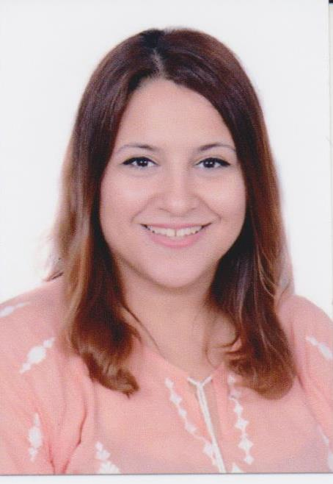
INAS
PERSONAL INFORMATIONS:
Abu Dhabi| +971501685421| inas.379311@2freemail.com
- Nationality: Egyptian.
- Date Of Birth: 11th August 1985.
- Marital status: Married.

PROFSSINAL SUMMARY:
Motivated dentist specialized in cosmetic dentistry with a track record of excellent organizational and interpersonal skills, keen to secure a position with a dynamic and progressive dental practice.

EDUCATION:
- Cairo University, Faculty Of Oral and Dental Medicine.
Master degree in fixed prosthodontics, June 2017.
- Title of the master degree thesis: Effect of long term storage and thermo-cycling on the vertical marginal gap distance and micro-leakage of CAD/CAM provisional restoration material in comparison to self-cured composite provisional restoration material.

- Fulfilled the practical requirements of all fixed prosthodontics, opretive and endodontic departments required to master the different restorative techniques.

- Cairo University, Faculty Of Oral and Dental Medicine.
Bachelor Of Science, May 2008.
Grade: Very good with honor degree.

- Al Murijeb School, Al.Ain, UAE.
High School Certificate, June 2003.

Extra educational courses:
- Cosmetic Dentistry Course with Dr. Mohamed Shams through the Egyptian society of Oral Implantology (ESOI), an ADA continuing education program, April 2017.
- Health care and hospital management diploma through the Community Service Center and Continuous Education Unit, Cairo University, 2010.

LICENSURE:
- Passed the DHAGeneral Dentistry License exam, 18th January 2018.
- Egyptian Ministry Of Health practice License.

WORK HISTORY:more than 6 years of experience were practised as follows:
- Specialized Dentist at Healthy dental Center Cairo, Egypt.
July 2017 – till recently.

- Dentist at Al-Hassan Ali Al-Haggar dental clinic Cairo, Egypt.
March 2015 – April 2017.

- Dentist at Al-Hassan Ali Al-Haggar dental clinic Cairo, Egypt.
January 2013– June 2014.

- Dentist at Al-Marmar Poly Dental Clinic Riyadh, K.S.A.
July 2010 – July 2011.

- Dentist at Whity cosmetic and dental clinic Cairo-, Egypt.
January – June 2010.

- Dental Assistant at the Egyptian Center for Dental and Maxillo-facial surgery Cairo, Egypt.
May – December 2009.

- Intern at the hospital of the Faculty of Oral and Dental Dentistry, Cairo University Cairo, Egypt.
May – October 2009.

- Intern at Al-Nozha Center for family medicine Cairo, Egypt.
November 2008 – April 2009.

HIGHLIGHTS:
- Well presented and articulate.
- Excellent listening, communication and inter-personal skills.
- Self motivating and highly organized.
- Ability to work independently and be proactive as well in a team environment.
- Ability to work under pressure and meet corporate requirements and commitments.
- Ability to maintain quality, safety and infection control standards.
- Excellent command of both English and Arabic.
- Skillful with Microsoft Office.
- Always keeping up to date with the latest developments in dentistry.

REFRENCES:
- Available upon request.

