CURRICULUM VITAE

SANJAY

C/o-Mobile :+971504973598

E-mail : sanjay.379316@2freemail.com

CAREER OBJECTIVE

A good position in a dynamic and avant-garde company that can utilize my acquired skills effectively with enhanced job responsibilities, continued growth and advancement.

Currently on Visiting Visa andofUnitedstayingArabinkarama,EmiratesDubaiandstaying on Karama, Dubai Visiting Visa has valiadity till May 2018.

PROFESSIONAL SYNOPSIS

� An MBA graduate along with B.COM having nearly 8 years of experience in the field of Payroll Management, HR service, Credit/ Debit collections, Customer service and Banking/ Insurance service.
� Ability to handle the Finance department independently , Payroll calculation and processing , Client management directly and via tele-communication, customer service, Marketing and sales..

� Proficient in MS Excel & MS Word. Expert in English language, pleasant personality with excellent communication skills.

� Well versed in negotiation and maintaining client relationships.
� Well versed in presentation of complex financial data to facilitate decision making. � Proficient in computation of corporate and individual taxes.

� Efficient in maintaining clear cut and accurate records with excellent technical skills. � Worked only on Multi-National Corporate companies in all the working years.
� Effective communicator with excellent relationship management and inter-personal skills.
� Affable, hardworking, sincere and adaptable to any working situations and a continuous learner.

ORGANISATION:

DURATION:

POSITION:

� Payroll calculation and HR analysis of UK payrolls
� Closely associated with the clients by providing required documents for clearance of payments, handling client queries, providing client support and visiting client places when required.
� Undertaking temporary roles for Payroll analysis for project implementation for new projects of the firm � Quality verification of payroll calculations of HR department to analyze the accuracy of payroll and HR
department and reporting in case of discrepancies.
� Acting temporary managerial post at the absence of Managers � Preparing report on receivables to support managerial needs.

ORGANISATION: Charter Mercantile Agency (Australian Company)

Tapasya Building, Infopark, Kakkanad, Kerala, India -682030

DURATION: 14 Nov 2011 to Mar 31 2016

POSITION: Senior Collection Executive

� Credit and Debit collections for Australian American Express customers.
� Reporting to the Collection Manager on the key factors affecting the fund collections. � Participating in managerial discussions on collection process

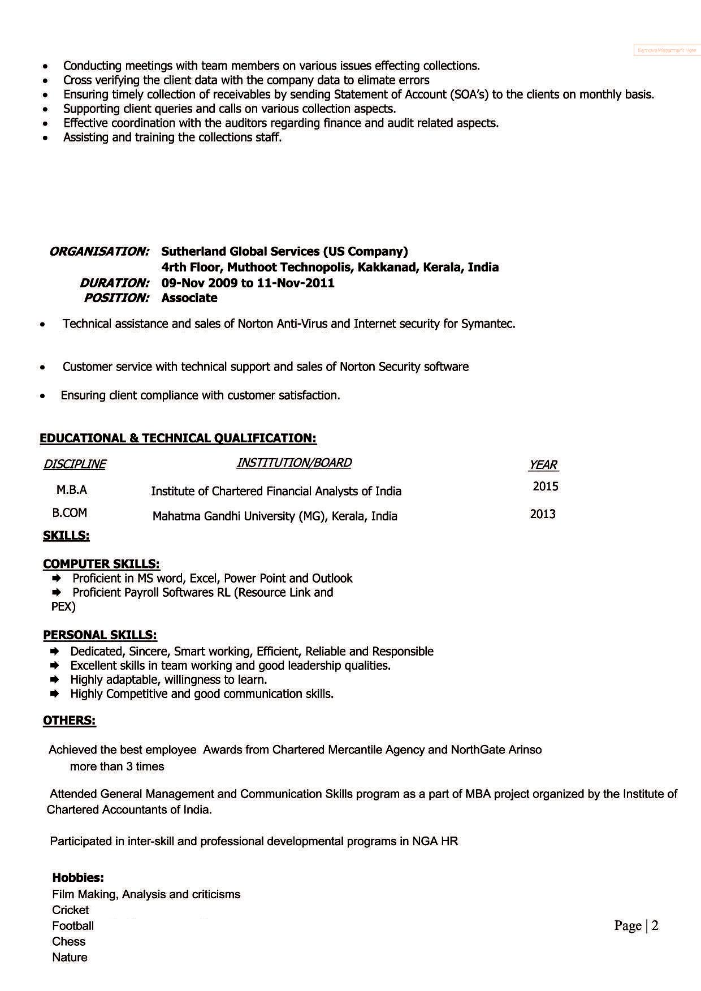
Page |

