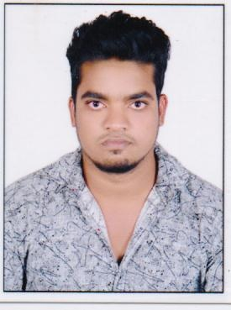
CURRICULUM VITAE

PRASAD
C/o- +971505891826
Email: Prasad.379319@2freemail.com

Seeking a suitable position to utilize my skills and abilities in the field I look forward to pursue a career pre dominantly in the field where I can use my relevant experience and academic background that exploits my abilities maximum while providing me wider exposure and opportunity to utilize my service to the organization seeking expansion and growth

PERSONAL DETAILS
Nationality : Indian
Sex : Male

Religion : Hindu

Civil Status : Single
Date of Birth : 06/08/1995
Visa status : PermanentVisa
EDUCATIONAL QUALIFICATION
- HIGHIER SECONDERY
- B.COM-(-2012-2015-)

WORK EXPERIENCE
- Worked as DOCUMENT CONTROLLER in FIRST GULF BANK HR department ABU DHABI (2014-2016)
- Custodian of filling room and safe keeping of HR employ.
- Working as SALES MAN In AL MARAI ABU DHABI
DRIVING LICENCE

Issue date : 19-06-2017
Expiry date : 26-06-2027
Place of issue : Dubai

Languages Known
- ENGLISH
- HINDI
- TELUGUE
DECLARATION
I do hereby declare that the above information’s are true correct and complete to the best of my knowledge & belief that I am in possession of the documents in proof of the claim made in the application.

PRASAD

