SHEBIN
Admin Assistant & Accounts Support – 10.5 years’ experience Self -motivated, flexible, adaptable and possess structured approach towards assigned tasks. Excellent skills to work under pressure and deliver results as per the benchmark set by the organization

Location Preference: UAE

Key Impact Areas

General Administration (Visa Processing Support/ Insurance, Vehicle Management) Human Resource Management Accounts Support

Invoicing/ Accounts Payable & Receivable Bank Reconciliation

Petty Cash
Management

Reporting

Liaison & Coordination

Trade License Renewals

Government

Department

Technical Skills

MS Office (Excel, Word, PowerPoint)

Visace Gold A/C | Horizon Accounts Software | Data Entry

Omni Docs Software - Omni Scan | Oracle NetSuite

Coke 1 Lite SAP (Cash Receipt/ Petty Cash)

AMS Software (ERP System)

Career Timeline

Shebin.379326@2freemail.com | +971 505891826
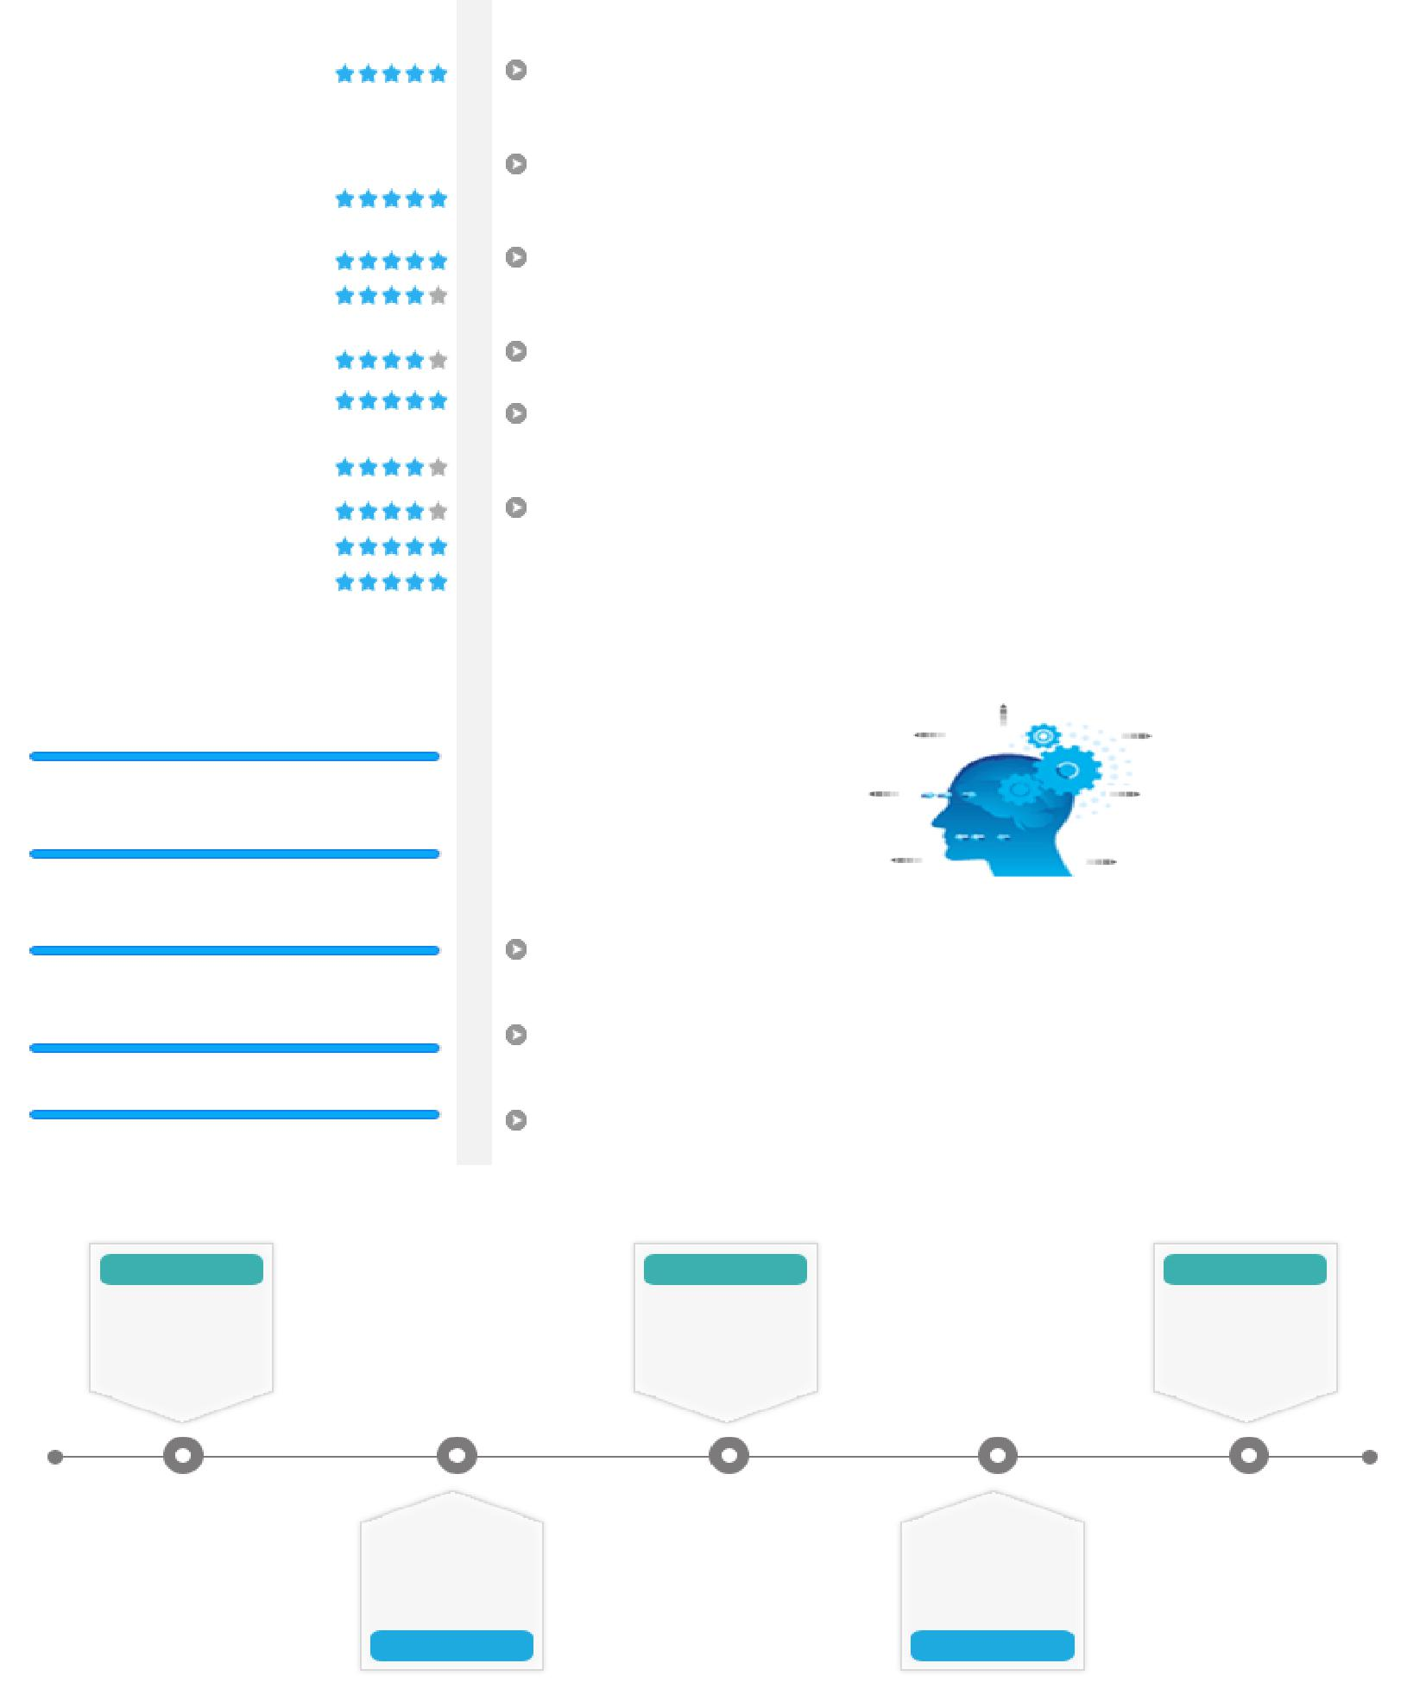
Profile Summary

Hands-on experience in providing high-end administrative support to the management by organizing calendar management, scheduling the meetings with internal team & employees

Proficient in development, implementation, evaluation & modification of administrative policies & procedures to optimize resource & capacity utilization across various functions

Capabilities in driving daily accounts payable & receivables processes, ensuring accurate processing of invoices, purchase orders, expense reports, credit memos and payment transactions

Proven capability to work with senior management to integrate administrative functions in line with overall business operations strategies Leveraged skills in making arrangements for travel, email management

- correspondence and organizing business seminars, arranging Visas (business & visit) and maintaining confidentiality in matters

A forward thinking person with strong communication, analytical & organizational skills; well organized with a record that exhibits self-motivation & creativity to achieve corporate goals

Soft Skills

Communicator

Innovator Thinker

Collaborator Intuitive

Team Player Planner

Education
B.Com. (Hotel Management & Catering Technology) scored 1st class, NAAC; B+ Grade, S.N. College and Varkala (University of Kerala, India) in 2004

One year International Diploma in Hotel Management Munnar Catering College, India (Affiliated to the Education Institute of American Hotel & Motel Association USA) in 2005

EMBA from NIBM India (Higher Learning Accreditation Commission of Texas, New York, USA), scored B+ Grade in 2016

2007-2009 | 2013- 2014 | 2016 till date
Aabharan | AGL-Coca-Cola, | Belhasa Biotek
Jewellery LLC | Dubai as Office | LLC as Admin.
(NMC Group) as | Admin. Assistant/ | Assistant &
Junior Officer | Accounts Support | Accounts Support

UAE Exchange | Mahani Auto Spare
LLC, UAE as Office
 | Parts as Office
Admin. & Office
 | Admin. Assistant &
Support (Logistics)
 | Accounts Support
2009- 2013 | 2014 - 2016

Work Experience
May’16 till date | Belhasa Biotek | LLC (Belhasa | Group International), | as | Admin.
 | Assistant & Accounts Support
 | Role:
 | Managing processing of Accounts Receivable (AR) including posting &
 | balancing of daily cash applications, preparing journal entries, filing of
 | records and general account reconciliations
 | Ensuring that all payables are entered accurately into the accounting
 | system, including a thorough description of each item
 | Receiving daily cash from salesmen & customers, depositing to bank
 | daily wise and providing reports to Manager
 | Posting cheque and cash transaction in accounts system
 | Working on various HR activities such as:
 | O Organizing work space for new employees
 | O Updating personnel files and employee status changes
 | O Administering leaves of absence
 | O Reviewing annual performance reviews
 | Resolving accounts discrepancies with customer and suppliers after
 | proper checking with concerned dept.
 | Ensuring:
 | O Proper recording & application of cash, management of outstanding
 | invoices; directly interfacing with customers on collection matters
 | and resolution of disputes
 | O On-time completion of joining formalities, on-boarding & induction
 | of the new joinees
 | Preparing:
 | O Vouchers (cash, bank) and TT
 | O Leave, absenteeism, over time and staff fine related vehicle reports
 | to HR
 | Steering employee travel expense calculation and submit for concerned
 | Manger approval
 | Coordinating with:
 | O Insurance | company for | employee insurance card | & | vehicle
 | (accident & renewal) related insurance
 | O Government department for company needs (Renewal)

- Office stationery management

- Travel ticket for employees via Online and travel agencies

Ensuring utilities bill payment on time (electricity/ telephone)

Jun’14 – May’16

Mahani Auto Spare Parts Company (Sharjah/ Dubai) as Office Admin Assistant & Accounts Support

Responded to customers’ complaints and took necessary action to resolve their issues
Received payment in exchange of items or merchandise sold

Entered transactions in the cash register and provide customers with the total bill

Developed reports (total outstanding report monthly, yearly, pdc/ c.cheque/ chq rtn. report)

Verified the customer history of payment & provided the credit control department for processing credit application

Provided monthly accounts statement for customers on time for cheque preparation and collected the cheque from the office on time Ensured cheque preparation for suppliers as per SOA

Coordinated with suppliers & customers and maintained the documents Maintained the records of office inventory Managed:

- Leave, absenteeism, over time and provided reports to HR
- Branch renewal and PO renewal details
- Travel ticket for employees via Online and travel agencies
- Visa Processing Support and Insurance Card Coordination
Made utilities bill payment on time

Apr’13 – Jun’14 AGL-Coca-Cola, Dubai (Regional Head Office) as Office Admin.
Assistant/ Accounts Support

Role:
Created PO in Coke One Lite SAP for office stationery for HR, Sales,

Warehouse and other depots approved by concerned line manager
Confirmed with transporting department regarding vehicle fine and

charge the same in employee GL in SAP
Entered all petty cash entry (DXB, Sharjah, NE) in SAP with proper GL

before month-end
Collected and delivered all banking documentation from and to banks to
ensure effective and timely processing of banking transactions
Filed the playable and purchase orders together in a systematic way
Checked DCR (Daily Collection Report) for Dubai, Sharjah, NE Depots
Managed petty cash (monthly 400000 AED) for PRO & daily operations
Prepared:
O New employee joining reports and sent request for create employee
IDs
O Sick, annual and other leave and reported to HR before Payroll

Jul’09 – Mar’13 UAE Exchange LLC, UAE as Branch Support (Logistics)

Role:
Ensured availability of stationery for branch operations all over UAE (99
branches) through AMS
Performed asset auditing and submitted to Finance Department for
valuation of asset
Scanned and uploaded the confidential & employee documents in Omni
Docs/ Omni Scan
Assisted:
O CSM (Centre Store Manager); ensured payment of all admin related
bills and maintained register for the same
O HR recruitment process (sorting CV, informing candidate for
interview scheduling)
Uploaded over 700 documents in Omnidocs System after labeled by

customer reg. no.
Contributed as team member of three major HR projects of UAE

Exchange (DMS/ AMS/ MMS projects)

Sept’07 – Jul’09

Certification

Personal Details

Aabharan Jewellery LLC (NMC Group) as Junior Officer – Cashier/ Sales

CISCP (Certified International Supply Chain Professional) – IPSCMI, USA (Blue Ocean Academy, Dubai) scored 71% marks

Date of Birth: 15th March 1983
Languages Known: English, Malayalam, Hindi, Tamil

Marital Status: Married

Visa Status: Employment Visa
Nationality: Indian

Driving License: UAE Driving License, Indian Driving License

