RESUME
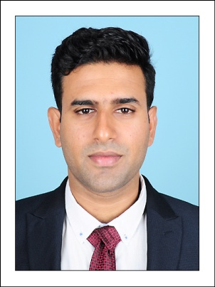
PAUL
C/o- Mob: +971501685421
E-mail: paul.379331@2freemail.com
B.Tech in Electrical and Electronics Engineering

PERSONAL DATA

Date of Birth : 24/02/1993
Sex : Male
Nationality : Indian
Marital Status : Single
Languages :English, Malayalam
&Hindi
Visa Status : Visit Visa
CAREER OBJECTIVE

To work on a challenging job profile which provides opportunity to utilize my professional skills and enrich my knowledgefor helping the process of achieving professional, organisational and personal goals.

KEY STRENGTHS

- Willingness to do challenging work
- Self confidence and patience
- Adaptability
- Dedication to work & Organisation
- Effective time management
PROFESSIONAL EXPERIENCE

Bharathi Electronics, Kerala - India
Period : January 2016 – June 2016
Job Profile : ASSEMBLY & MAINTENANCE OF AUTOMATED LEVEL
CONTROLLER
Leela Electric Power Services Pvt. Ltd,(Class ‘A’ Electrical Contractors)
Period : November 2016 – March 2017
Job Profile : SUPERVISING TRANSFORMER & PANEL ERECTION,
HT & LT WORKS
EDUCATIONAL QUALIFICATIONS

- B.Tech in Electrical and Electronics Engineering
- University :Singhania University
- College : Singhania University,Pacheri Bari,
Juhunjhunu, Rajasthan
- Year of passing :2015
- Percentage : 72.3%

- Higher Secondary (XII)
- Board :Board of Higher Secondary Education,
Kerala
- School :Mar Coorilose Memorial Higher
Secondary School, Pattimattom
- Year of passing:2010
- Percentage :80%
PROJECT WORKS
ACADEMIC PROJECT

- Mini Project : “CELL PHONE OPERATED LAND ROVER”

- Main Project:“DEVELOPMENT OF CONTROL & MONITOR
INTERFACE” done at Naval Physical &
Oceanographic Laboratory(NPOL)
SOFTWARE SKILLS

Languages :C++
Computer Applications :MS-Office (Word, Excel, Powerpoint)
Designing Software :AutoCAD & Revit MEP

Paul (Resume – page 2 of 2)

