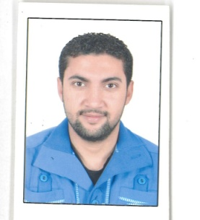
Personal Information:
Name: Hamdy
Date of Birth: 14/8/1989
Place of Birth: Egypt
Nationality: Egyptian

Education: Institute of Technical healthy Beni Swef. Radiology Department(X-Ray Technician)

Experiences:
- 6 years in X-Ray Technician& with contrast.
- Barium enema &barium swallow &barium meal.
- Ascending on bladder& IVP on kidney.
- 6 years in Dental X-Ray &Dental CT (CBCT).
- 2 years in Medical compound of the armed forces of (KOBRY ALKOBA).
- Digital Panoramic & Cephalometric & Cephalometric .
- Analysis (Tracing) .
- Hand Wrist Radiography & Periapical.
Computer skills: Microsoft Office programs, accounting programs and Internet skills

Personals skills: Ability to work closely with the team, to accomplish work in a short time, with high quality,

Other Certificates :
- College of Medical Sciences.

Languages: Arabic& English
Contact Information:

E-mail: hamdy.379332@2freemail.com & Mobile: +971501685421

