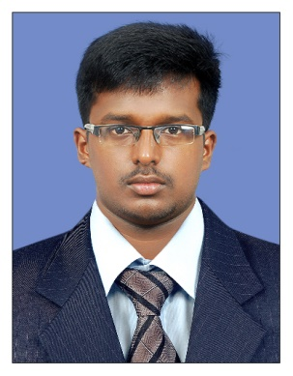

C/o- UAE - +971503718673
i

Vishnu.379339@2freemail.com

VISHNU

OBJECTIVE
WORK EXPERIENCE
2 Year
To discharge the entrusted functions efficiently and to improve myself to be an indispensable asset for the organization. Where I can utilize my skills and talents to make a tangible contribution in its growth and profitability.

VISA STATUS
3 MARCH – JUNE 7
Work Experience

- July 2016 – Dec 2017 ISLAND SHIPPING AGENCIES PVT LTD COCHIN, INDIA
CUSTOMER SERVICE / OVERSEAS EXECUTIVE /BPO EXECUTIVE
- Selling services of the fraternity to the importers, building revenue of AED 50000 in 6months.
- Coordination with international competitors and deriving benefits to the firm.
- Built up the strong rapport with client and generate the trust for future retention.
- Always focus on service and provide the maximum updates for brand recall.
- To liaise with customs, port authorities, shipping lines, CFS in Berlin and Australia.
- Ensuring and coordination with consignees around the world mainly US and Australia.

- June 2015 – May 2016ATLANTIC SHIPPING COCHIN
OVERSEAS FREIGHT EXECUTIVE
I was induced into a prominent shipping agency which evidently handling fleet vessels :

- To prepare accounts receivable & payable, journalisation of all activities of the vessel.
- To coordinate with shipping line and ports in Australia and US.
- To handle customer service department sector for US.
- To make port call ,vessel amendment in india.

Education

Masters, Business Administration in Logistics and shipping Graduated, July 2016
Institute of logistics and shipping Marks 61%
Chennai India I ^{st} Class
Bachelor in Commerce Graduated, July 2011
St Paul’s College Kalammassery Marks 64%
Cochin Kerala I ^{st} Class

INTERNSHIPS

FREIGHTCONNECTIONSINDIA LTD
Attended 3 Month Internship in a prominent Shipping line in Mumbai.
BOLLORELOGISTICSINDIA
Had been a trainee in BOLLORE LOGISTICS INDIA LTD (Formerly known as SDV) to confer information upon the project namely: EXPORT PROCEDURE AND DOCUMENTATION IN AIR FREIGHT

Language Proficiency

- Hindi
- English
Personal Details

Father’s Name: Mr. Murukesan N Marital Status: Single
Birthday: September 12, 1992 Nationality: Indian
Gender:
Reference

