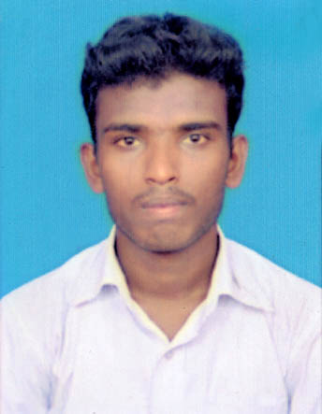
CURRICULUM VITAE

RAMAR
C/o- Mobile no: +971501685421
E-mail: ramar.379341@2freemail.com

OBJECTIVE:

Intend to build my career in an organization with commitment and dedication and willing to work in a challenging environment which will help me to explore myself to realize my potential.

EXPERIENCE :

TVS Sundram Fastener Limited, Autolec Division, Chennai, Tamil Nadu
(Follows ISO : 14001 : 2004, TPM, ISO/TS 16949 : 2002 certified)
Duration :MAY 2016- OCTOBER 2017
Designation :Engineer Trainee -Quality Assurance& Quality Control Inspector
Company Profile :The Autolec Division has been in existence from 1965 and is today one of the leading manufacturers of Pump Assemblies and Engine Components. Customers are Greaves Cotton, Kirloskar Engines, SAME Engines, Simpson, Tata Cummins, Swaraj Engine, Tata Holset,.etc.

PERFECT GEAR PVT LTD CHENNAI,TAMILNADU
(ISO 9001 : 2008 certified by TUV)
Duration :JAN 2016-MAY 2016
Designation : Engineer-Quality Assurance

Roles and Responsibilities :

- Execute first off and patrol inspection as per check sheet.
- Capture process capability at specified interval adherence to cp and cpk monitoring plan for once in every month.
- Monitoring and examining each stage of production.
- Carrying out final inspections.
- Layout inspection report verification and take corrective action for deviations.
- Critical parameter verification and take corrective action for deviations.
- Do the process capability study for the Critical parameters.
- Take Permanent corrective action for Customer Rejections and complaints.
- Prepare monthly quality report for once in every month.
- Materials selection for press tools and checking fixture.
- Proficient in Quality standards7 QC tools and QC story.
- Worked extensively with measuring instruments and gauges and awareness about gauge calibration.
- Knowledge in handling 2D height gauge, Roughness Tester & Roundness testing machine, contour machine, profile projector, Millipore testing.

EDUCATION QUALIFICATION:
Qualification | Year Of passing | Board/University | Institution | Percentage Of Marks
B.E(MECH) | 2015 | Anna University | Tagore Engineering College,chennai. | 6.58(CGPA)
HSC | 2011 | State Board | Maruthi Higher secondary school,Attur. | 78%
10th | 2009 | State Board | Government Higher Secondary School, Adari. | 79%

TECHNICAL SKILLS:
- Auto Cad 2010
- CNC machines

ACADEMIC PROJECT:

- Main Project on ““EFFECT OF HEAT INPUT ON BORATED STAINLESS STEEL (304B) GAS TUNGSTEN ARC WELDS.””.

STRENGTH:
- Ability to move within a Team and share my ideas and Vision.
- Leadership qualities.
- Interest in learning new technologies.
- Positive attitude.

PERSONAL PROFILE:
Gender : Male
Marital status : Single
Date of birth:05-05-1994
Languages Abilities : English(R/W/S),Tamil(R/W/S)
Nationality : Indian

DECLARATION:

I hereby declare that the information furnished above is true to the best of my knowledge.

