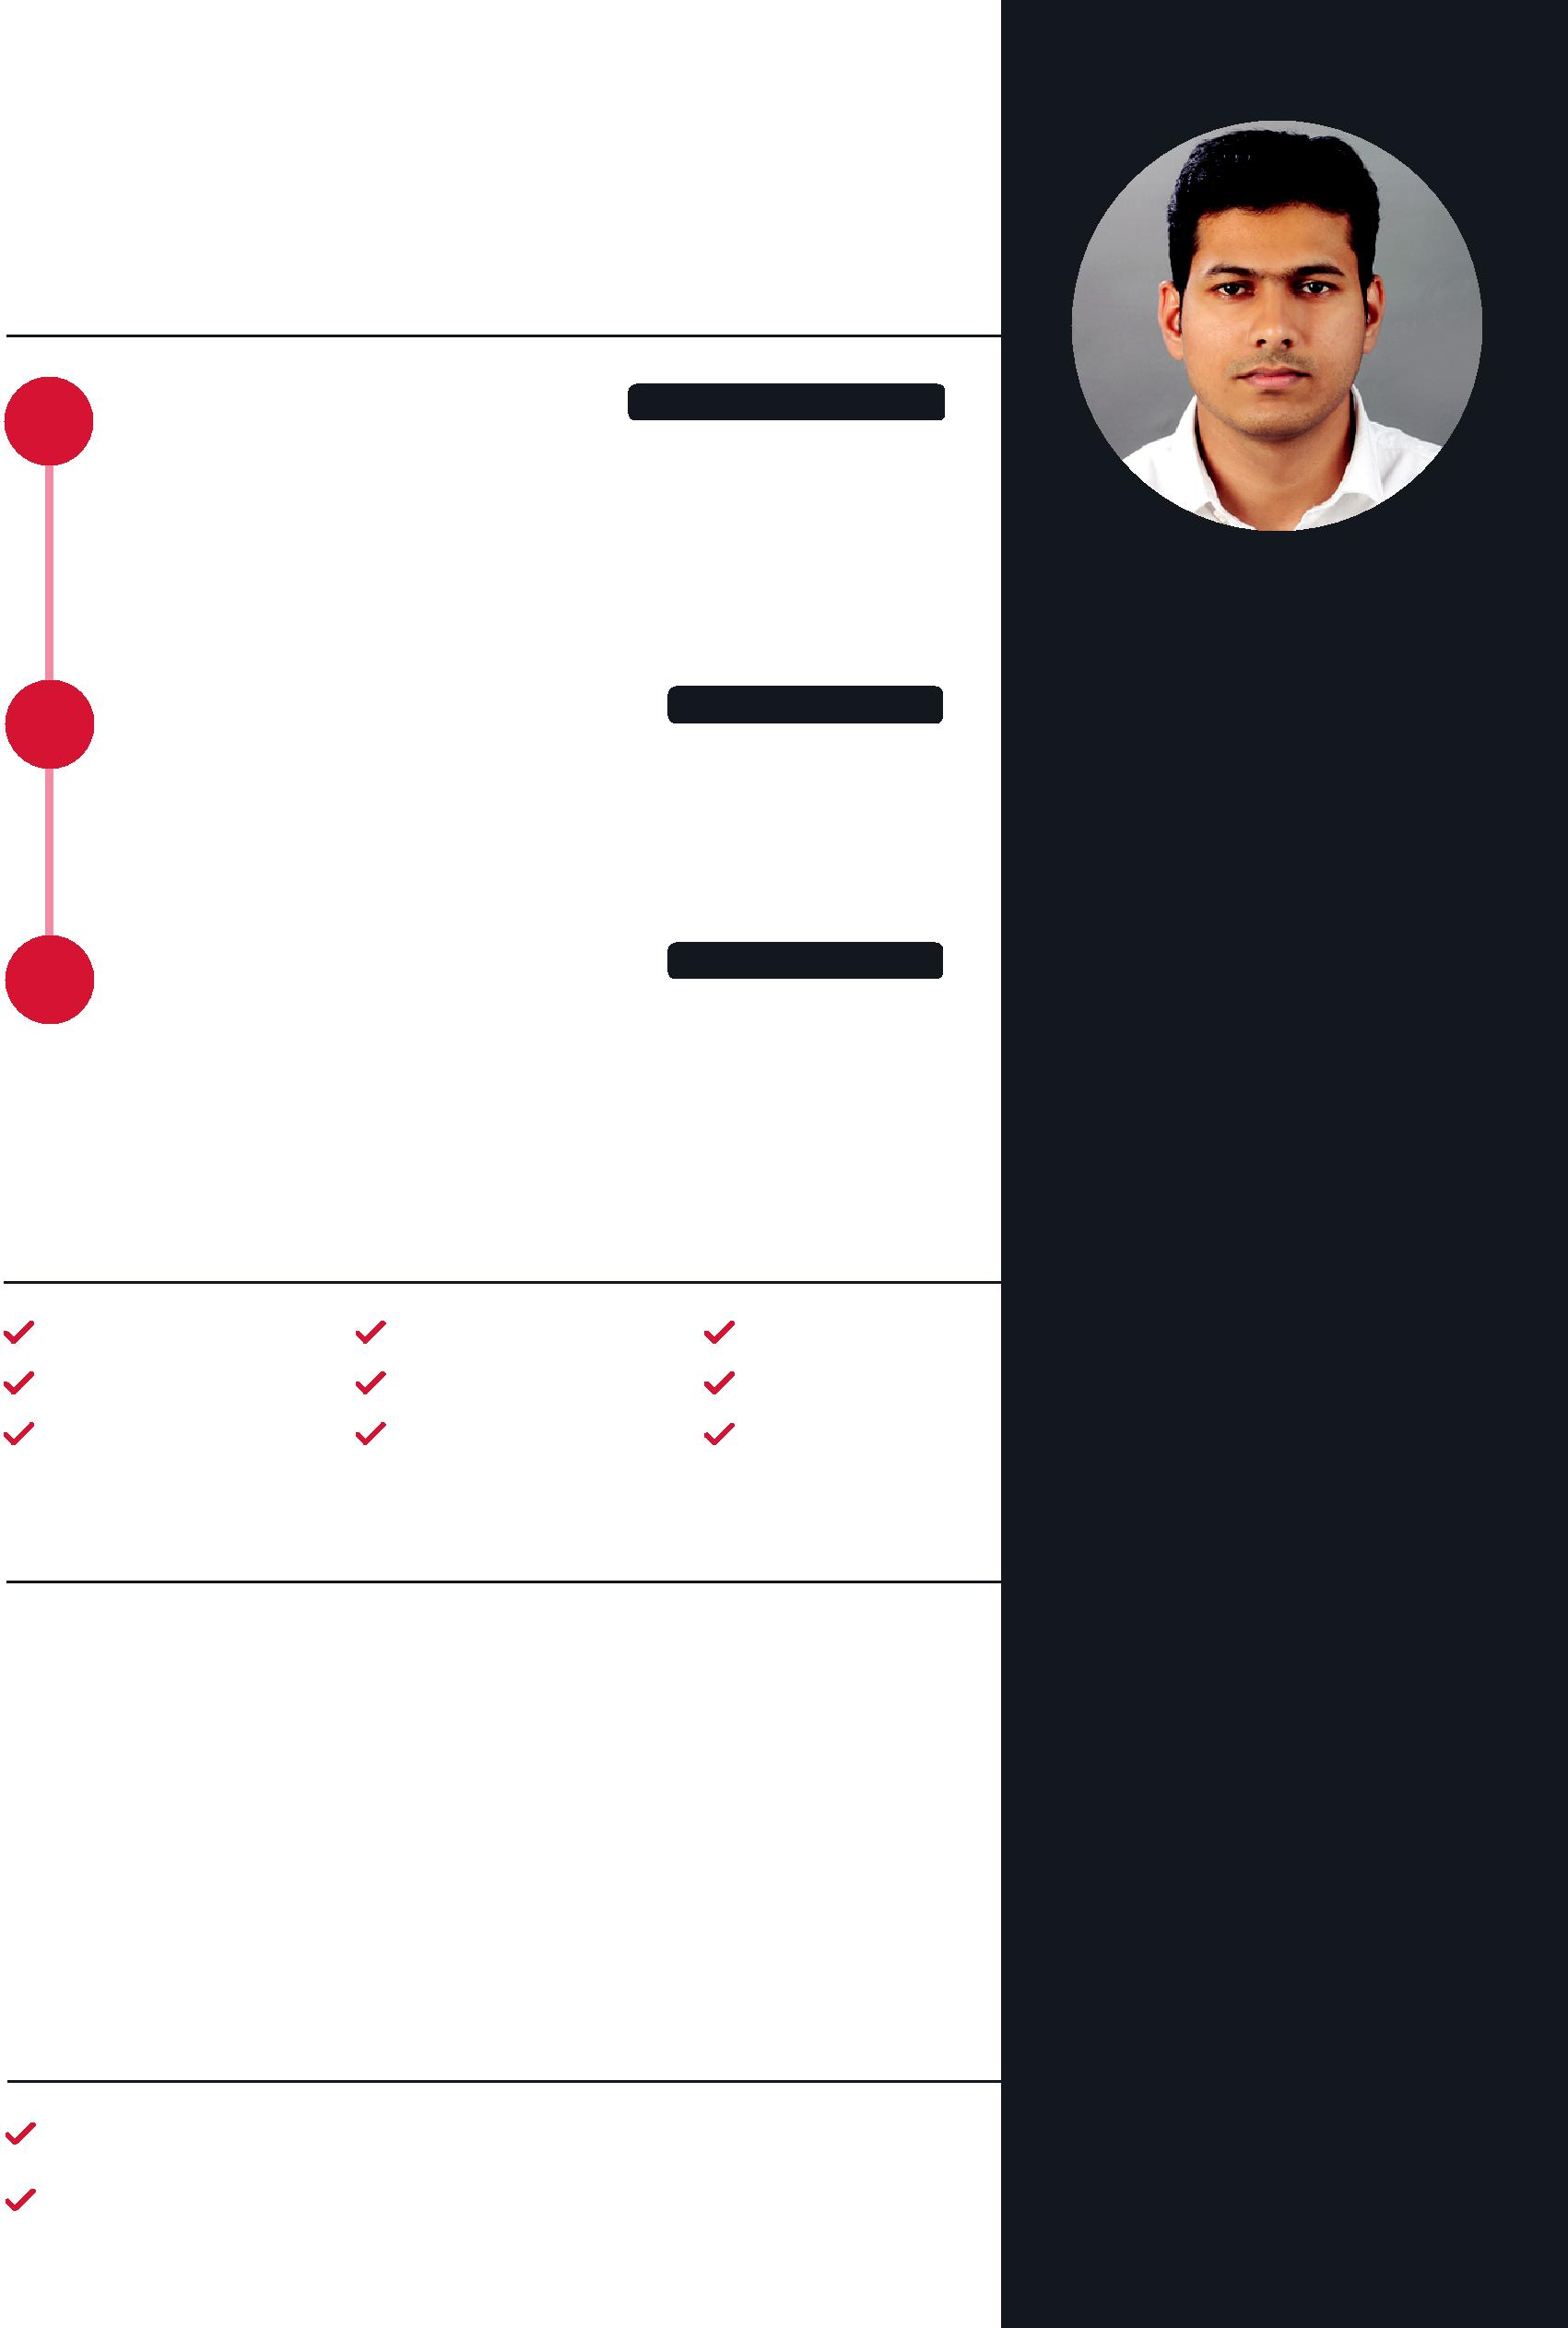
SUBIN
Subin.379367@2freemail.com
WEB DESIGNER & FRONT-END DEVELOPER

WORK EXPERIENCE

SENIOR WEB DESIGNER

TechWyse Internet Marketing / May 2015 - Jan 2018

I worked as a Senior Web designer and Front-end developer in Cochin (India) office. My main responsibilities in TechWyse included Web design, HTML conversion, & WordPress integration.

------------------------------------------------------------

WEB DESIGNER www.caxita.com

Caxita Tech Solutions / Dec 2013 – Apr 2015

My responsibilities in Caxita were Web design, Logo design and HTML conversion.
------------------------------------------------------------

WEB DESIGNER www.almeka.net

Almeka Technologies / Feb 2012 – May 2013

My responsibilities in Almeka were Web design, HTML conversion and making Adobe Flash animation ads.
------------------------------------------------------------

SKILLS

Adobe Photoshop | Adobe Illustrator | HTML5
CSS3 | SCSS | Bootstrap
Wordpress | jQuery | Dreamweaver

PROFESSIONAL EDUCATION

Training in Web Designing / 2009

Attended 6 months of training in Web designing from Z-Media Entertainments, Calicut(Kerala)
----------------------------------------------------------------------

Multimedia and Animation / 2011

Completed one year course in Multimedia and Animation from Alphatech Computer Centre, Nilambur(Kerala)
----------------------------------------------------------------------

ACADEMIC EDUCATION

Bachelor's Degree / 2010 Plus Two / 2006

SSLC / 2004

PROFILE

Based in Kerala, India, I’m specialized in web design and front-end development with a flair in producing high-quality and responsive websites with stunning user experience. In my 5+ years of work experience, I’ve been fortunate enough to have worked for various clients from India, Canada & Gulf countries.

PERSONAL DETAILS

Date of Birth | 29 June 1989
Gender | Male
Marital Status | Single
Nationality | Indian
Languages | English, Hindi &
 | Malayalam

