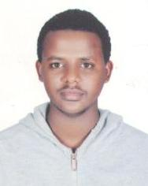
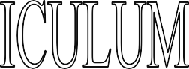

ERMIAS
Email: ermias.379405@2freemail.com

D U B A I – U AE

PERSONALINFORMATION
Date of Birth : 25 July,1988
Gender : Male Marital Status : SingleNationality : Ethiopian Visa Status : Employment
OBJECTIVE
Highlyskilledandindustriouswaiterwithademonstratedabilitytoperformanddeliverthebest customerservicesindependentlyaswellasinateamwithtestedskillsinprioritizingandfinishing multipletasksintimeandinahighlyorganizedmanner.Iamabletograspnewconceptsandtake initiative in coordinating hotel and restaurant activities and achievingtargets.
KEYCOMPENENTS
- Cheerful, enthusiastic &innovative
- Young, aspiring, hardworking and dedicated innature
- Able to work well in a team/group or independently under minimalsupervision
- Perform assigned task with greaterresponsibility
- Friendly and pleasantnature.
- Have good communication skill inEnglish
- Can work under pressure and meetdeadlines
PROFESSIONALEXPERIENCE

 Waiter(Nov2013–Nov 2016),Harmony International hotel, Addis Ababa–Ethiopia.
  Waiter (Aug2016–July 2017),Ramada AddisHotel,AddisAbaba– Ethiopia.
 Reception (Jan 2016- July 2017),ElianaInternationalHotel,AddisAbaba– Ethiopia.
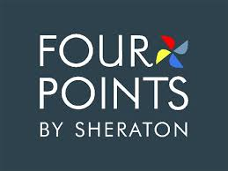 Currently I am working in four points by Sheraton hotel in Waiter position.

Responsibilities
- Greet guests and accompany them to theirtables
- Providing a warm welcome for guests and making recommendations from themenu.
- Provide an excellent customer service that anticipates individual guestneeds
- Supervise restaurant services duringshifts.
- Bring dishes/ drinks to the table and clear dinner plates, serving dishes and clearingcutlery

- Make recommendations of which drink to accompany guestmeals
- Prepare and set tables for the nextguests
- Ensure the food service area is left clean and tidy once all the guests haveleft
- Provide drinks service to the tables in the bar, asrequired.
- Ensure the guests receive high quality services and serviceprovision.
- Seek out guests to assist and offerservice.
- Ensure all opening and closing duties were performedproperly.
- To maintain the areas to a very high standard ofpresentation.
EDUCATION /COURSES
- Diploma in HotelManagement
- High School Leaving CertificateExam
- Computer application and InternetBrowsing
LANGUAGES
- English Fluent
- Amharic Native
PASSPORTDETAIL
- Date of Expiry : 29 Mar,2016
- Date of Expiry :28Mar,2021
HOBBIES
- Reading Books
- WatchingMovies
- Swimming

I hereby declare that the information furnished above is true and correct to the best of myknowledge.

