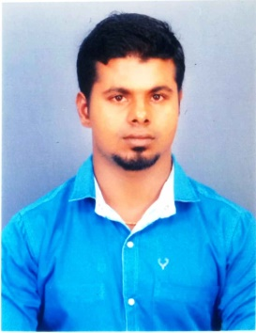
SALES ASSOCIATE
ANTONY
Email: antony379412@2freemail.com

PERSONAL SUMMARY
Looking for a sales associate position and support the sales team in scoring, displaying and selling of merchandise with my customer service skills.
PROFESSIONAL SKILL
- Excellent communication, interpersonal, and customer service skills
- Complete knowledge of safety policies and practices
- Skilled in understanding customers' requirements and giving product demonstrations
- Ability to handle cash and maintain stock of a retail setting
- Strong mathematical, computer, and organizational skills
- Skilled in taking stock and maintaining inventory
EDUCATIONAL QUALIFICATION
- Completed MBA GENERAL (Distance Education) from MS University, Tirunelveli, India 2017
- Completed BSC MATHEMETICS from MS University, Tireunelveli, India 2015
- Completed TALLY from AXN InfoTech, Tirupur, India 2016
COMPUTER SKILLS
- Good knowledge of Microsoft word, excel, access and power-point.
CAREER HISTORY
- Worked at HOTEL SINGAAR INTERNATIONAL, Kanyakumari, India as SALES ASSOCIATE ( 10/01/2017 to 31/02/2018)
Nature of Job Assisting customers in finding required products among the isles of shelves, Providing information to customers about product features and usage, Displaying products on the shelves and dusting them regularly to appear new, Stocking all the products on the shelves and in the store properly for easy access, Ensuring work area and the aisles are clean and is free of any sorts of odor

- Worked at SS HOTELS, Tirupur, Indiaas SUPERVICER (10/06/2015 to 10/11/2016)
Nature of Job:Guided and assisted customers on purchasing, Ensured smooth functioning between the store room and the sales floor, Coordinated with the sales and purchase team and colleagues and ensured no 'out-of-stock' situation, Thanked customers sincerely and ensured they visit the store again with helping them in packing materials
KEY SKILLS
- Having a responsible attitude, remaining calm under pressure
- Possessing superb decision making skills.
- Flexibility in working conditions
- Able to build a positive rapport with staff.
- Having good people management skills.
- Efficient with an excellent work ethics.
- Calmly responding to accident and emergency situations.
PERSONAL PROFILE
- Date of Birth : 27/04/1993
- Nationality : Indian
- Marital Status: Single
- Languages: Tamil, English, and Hindi
- Hobbies : Gardening, Fishing, Playing Football
DECLARATION
I, hereby declare that the information furnished above is true to the best of my knowledge and belief

