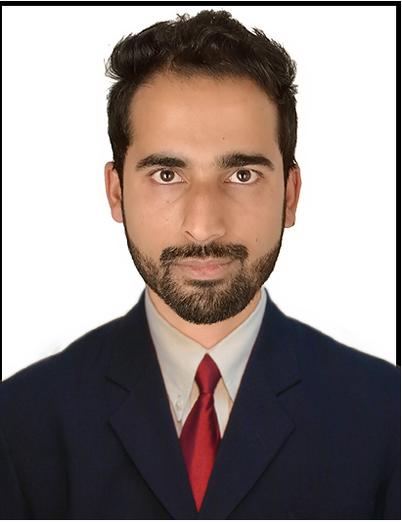

YASIR
Email-Id: yasir.379421@2freemail.com

Profile Snapshot
- Experienced professional with a successful career in insurance, business development, and accounting
- Excel at interfacing with others at all levels to ensure organizational goals are attained
- Proactive approach has resulted in capturing numerous accounts and expanding client base
- Possess excellent insurance,accounting , and organizational skills
- Excel within highly competitive environments where leadership skills are the keys to success
- An effective manager with the skills necessary to direct, train, and motivate staff to its fullest potential

Highest Qualification
Masters in Commerce (Finance) (2015)
India – Dr. C.V.Raman University
Bachelors in Commerce (2012)
India KA—Bangalore University
Additional Qualification: I year diploma in Computer Applications (DOEACC Chandigarh)
(Tally,Word,Excel,Access,Powerpoint,Visual Basics,Outlook)

Professional Summary

Bajaj Allianz General Insurance Company

Junior Officer Operations (Feb- 2015 to Nov-2017)

Key Contributions:

- Understanding the request and checking the necessary inputs in the request, in order to run the process smoothly
- Working on the assigned requests and achieving the target, with in the given SLA
- Ensure the issue is understood and well answered in a positive way to make sure customer is happy with the service
- Necessary endorsements and enhancements to be done as per underwriter guidelines
- Maintaining quality on the work, advising the team to ensure update the requests error free
- Assisting the new joiners and helping them to understand the process
- Assisting the chief accountant in cash collection and cheque receipting(Accounts receivables and Accounts payables)
- Multi-task professional: at times based on the situation played multiple tasks
- Team player: as a head of the Reporting, had to distribute the tasks to the entire team to work on it and revert back to me
- Once the report is collated ensure that it is filtered and presented in a way to be presented to the higher authority
- Reporting to the higher authority

INTERESTS AND HOBBIES
- Listening Music
- Playing PC Games
- Watching Movies

Passport Details:
Issue : 23/02/2015
Expiry : 22/02/2025

Personal Particulars

- Languages Known : English, Hindi, and Urdu. (Arabic –only to READ)

References

Will be provided on request

Declaration

I hereby declare that the above information provided is true to the best of my knowledge

