Darwish
Darwish.379484@2freemail.com
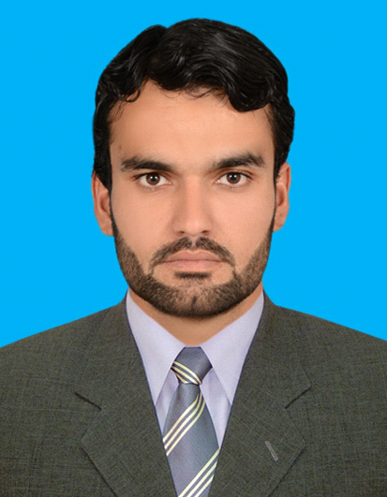
SUMMARY
Mechanical Engineer with a demonstrated history of 2 years and 6 months working experience in Steel re-bar rolling mills Production and Maintenance. Skilled in Pro-Engineering, Computer-Aided Design (AutoCAD), Microsoft Word. Strong engineering professional with a Bachelor of Science (B.Sc.) focused in Mechanical Engineering from University of Engineering and Technology, Pakistan
WORK EXPERIENCE
Production Shift Engineer Oct 2016-March 2018
Frontier Foundry Steel Rolling Mills, Lahore Pakistan
- Planning for roll and pass changing time in order to minimize the downtime.
- Supervision of Production team, Machine Shop team, fabrication team and contractors.
- Demonstrate and improve production processes to ensure greater mill efficiency.
- Work towards achieving departmental objectives and targets, etc.
- Correct billets size selection in order to avoid or minimize the wastage.
- Guide the pulpit operator for correct rpm of respective sizes through SCADA software.
- Checking of daily lab report and rolls mill ledger.
- AutoCAD design of different machinery used in Factory e.g. Roughing mills, Intermediate mills and finishing mills rolls, gears etc.
- Correct roll selection e.g. Adamite,SG iron etc. for roughing and continuous stands
- Noting the Mills faults during production.
- Hardness test of rolls and preparation of roll breakage report.
- Daily comparison of score sheet weight with actual scale weight for optimization of Production.
- Preparation of performance sheet of production team for Awarding after every month.
- Preparation of job for Rolling mills accessories like bearings, Belts and Pulley, Rolls, Plumber blocks etc.

Maintenance Engineer Sept 2015 – Oct 2016

FF Steel Pvt.Ltd (Frontier Foundry Steel Rolling Mills, Peshawar Pakistan

- Maintenance of all reduction gearbox, pinion gearboxes, conveyors, centrifugal pumps, helical gear, pumps, blowers, spur gear, Pinch rolls bearings Belts, pulley, chain sprocket etc.
- Maintenance of hydraulic and pneumatic system of rolling mills.
- Checking of spare list with fabrication and workshop team.
- Supervision of Machine shop e.g. lath machines 16ft,10ft,8ft and 6 ft. and shaper machine 18 inch,27 inch, drill machine up to 50 mm drill and hacksaw etc.
- Maintenance of roughing mills, continuous mills, pinch rolls, Y-table, Extension table, TMT (thermo-mechanical Treating) etc.
- Maintenance of Cooling bed cam and shaft mechanisms, twin channels cold shear, cold shear run out roller table and chain transfer etc.
- Correct selection of billets (CC and Balla) for deformed steel so to minimize the waste piece of deformed steel as much as possible as our standard length is 40 feet, we can also prepare the cut piece(other than standard).
- Ordering for new rolls and gears.
- Giving incentive for maintenance team for doing excellent maintenance.
- Daily meeting with management team of factory for smooth flow of Production.

Professional Skills
COMPUTER SKILLS

- AutoCAD
- Microsoft Office
- Pro-Engineer
- SCADA Software for rolling mills operation
- CNC Notching making and Branding machine
- C++ language
- CNC programing

SOFT SKILLS

- Teamwork
- Motivation
- Presentation
- Well communication
- Critical Thinking
- Problem Solving
- Time Management

PERSONAL DATA
Date of Birth 3 May, 1993
Current Resident: Dubai (UAE)
Visa Status: Visit Visa (long-term)
Nationality Pakistani

QUALIFICATIONS
BACHELOR DEGREE
Degree : B.Sc Mechanical Engineering
Grade : Good
Percentage : 74.25%
Session : 2011-2015
University : University of Egg &Technology Peshawar

INTERMEDIATE CERTIFICATE
Total Marks : 1100
Obtained Marks : 904
Percentage : 82.18%
Session : (2009-2011)

Institution : Govt. College Peshawar
Board : BISE Peshawar.

SECONDARY SCHOOL CERTIFICATE
Total Marks : 1050
Obtained Marks : 853
Percentage : 81.23%
Session : (2009)
Institution : Warsak Model School & College

