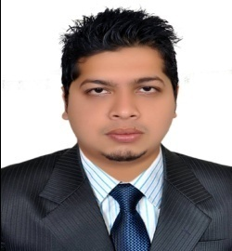
AHMED

E- Mail : ahmed.379522@2freemail.com

objective
To obtain a full-time position in the field, where I can practically apply and improve upon my management and operational skills. I am also more than willing to accept a position in an exciting new field that I have not yet had the opportunity to work in.

educational qualification
EDUCATION | INSTITUTES | YEAR | GPA
Masters of Business Administration | Iqra University Karachi, Pakistan | 2016 | 3.15
Bachelor of business Administration | Iqra University Karachi, Pakistan | 2013 | 3.00

PROFESSIONAL EXPERIENCE
- Carrefour Location: Dubai, UAE from Jan 2017 to Present
Working as Receiving In-charge, dealing with Suppliers on Material Ordering and Receivables, Assets Database Entry, Check and Follow up with Warehouse on Material Stock and maintaining the business cycle process in store.

- Meezan Bank Ltd Location: Karachi, Pakistan from Nov 2014 to June 2016
Worked as a Branch service officer, performs overall day to day operations of the bank, such as new accounts, customer service, and cheque related transactions.

- H.J Enterprises Location: Karachi, Pakistan from Jan 2013 to Oct 2014 Assisted with all aspects of administrative and HR management such as create and maintain database records, resolving day-to-day and weekly administrative problems, recruiting new staff and distribute payroll for staff.

ADDITIONAL SKILLS

- Excellent Communication skills with a focus on customer service.
- Focus to ensure that each task is completed correctly, efficiently, and effectively.
- Integrate into all team situations easily and comfortably.
- Utilize interpersonal skills to motivate and encourage co-workers.
      - Experience with MS office and Temenos T24 (Banking system software)
- 50 WPM typing speed.

personal information
Date of birth | August 14, 1990
Marital Status | Single
Nationality | Pakistan
Driving License | UAE Issued

DECLRATION
I hereby declare that the above given information is true to best of my knowledge.

