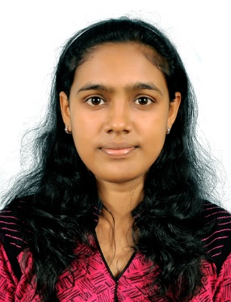
Malathi..379525@2freemail.com

MALATHI

OBJECTIVE

I am a sincere, loyal and dedicated individual who has a great deal of ambition. I am seeking a position for MEDICAL CODING where I can develop and excel while giving my best as an employee.

PROFESSIONAL WORK EXPERIENCE

Sutherland Healthcare Solutions Private Limited
[June 22, 2015 to Feb 3, 2018]

Team: Dignity [ED]

- Coded medical records with ICD-9, ICD-10, and CPT while initially processing 120-150 encounters on daily and maintained 100% accuracy and achieved 125 %productivity goals.
o Duties also included handling wide variety of medical records including Health and Vaccination, Surgery procedures.
o Worked on MS4, 3M, and Cerner software and coded accurately.
Used 3M software for the ICD and CPT codes.
o Worked for St. Rose, SNMH and St. Joseph Hospitals.
o Coded medical records with ancillary services processing 200-300
encounters per day with 100% accuracy.

Team: UVA [E/M]

o Performed Evaluation and Management Service (E/M Outpatient).
o On daily basis we receiving the client audit feedback.
o Department Coding Specializations Listed: Coded Outpatient services,
Emergency Service, Preventive medicine service, Gynecological visits.
o Handling of NOVITAS and NGS guidelines.
o Worked on EPIC software.
o Reviewing patient medical records and handled with ancillary CPT
codes, Vaccination Codes, Surgery codes and ICD-10 codes with the
100% production and 100% accuracy.
Team: UIC (E/M)
o Review patient’s e-medical records.
- Performed outpatient services, Emergency service, preventive medicine Service, Gynecological visits.
- Handling NOVITAS and NGS guidelines.

SKILLS

KEY SKILLS

o Good Knowledge in Anatomy & Physiology.
o Medical Terminology.
o ICD-9, ICD-10 Coding.
o CPT HCPCS Coding.
- Worked on internal auditor
- Trained new medical coder of my knowledge.
o A good team player

TECHNICAL SKILLS
Medical coding
o Specialty – ED/EM/CPT
oSoftware- 3M | Cerner| Citrix | Encoder Pro | OPTUM-360 | EPIC
o Computer skills: MS-Word | MS-Excel | MS-Power Point.

EDUCATION

o B. Sc (Biotech) |2013

Noorul Islam College of arts and science.

M.S University

Tamil Nadu

o M. Sc (Biotech) |2015

Noorul Islam College of arts and science.
M.S University
Tamil Nadu

KEY ACHIEVEMENTS

o Cleared AAPC Certification Exam CPC.
- Cleared Certification in Functional English examination from
IGNOU
o Received spot awards for the good quality in work.
o Awarded as “Employee of the month" for consistency in work.
o Research and Analysis of Patient Report.

PERSONAL DETAILS

Date of Birth 25.12. 1992
Age 25+
Gender Female
Nationality Indian
Marital status single
Mother tongue Tamil
Languages known English, Tamil, and Malayalam.

Declaration:

I hereby declare that the information furnished above is true to the best of my knowledge and belief.

