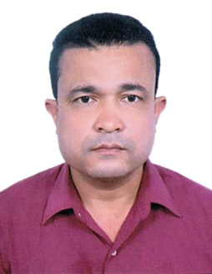
LAL
Nationality : Nepalese
Date of birth : 26.10.1974
Marital status : Married
Address : UAE
E-mail : lal.379541@2freemail.com

Personal Profile
A professional and has extensive experience security guard served for six years in Dry-docks World Dubai and two years in Golden Trishakti Security Service Nepal.

Professional International Experience

- 2012-2018 (March): Served as a Security Guard in Dry-Docks World Dubai.
- 2004-2006: Served as an English Teacher In Workers’ Children School, Nepal.
- 2001-2003: Served as a Security Guard in Golden Trishakti Security Service Nepal.

Training and Certifications
Training Name Organization

- DPS City and Guilds Dubai Police Academy
- Environmental Aspects Dry-docks world Dubai
- Security staff Training Dry-docks world Dubai
- Control and substance Hazardous Dry-docks world Dubai
- OHSE Management awareness Dry-docks world Dubai
- First Aid Fire Fighting Dry-docks world Dubai
- Safety Induction (HSE) Dry-docks world Dubai
- New comers course Dry-docks world Dubai
- Computer Course National Computer Center, Nepal.
- Security Training Golden Trishakti Security Service,
Nepal.
Educational Certification
High School Leaving Certificate Examination

Hobbies and interests
Jogging , reading books, etc

