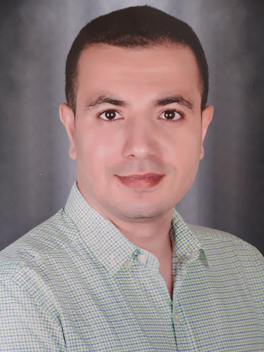

REFERENCES ARE AVAILABLE UPON REQUEST

**EDUCATION**

**EXPERIENCE**

**& TRAINING**

* **Asyut General Hospital, Egypt**

***2010-2012***

* Toshiba X-Ray Machine.
* Acoma X-Ray Machine.
* Swiss X-Ray Machine.
* Phillips Portable X-Ray Machine.

***Since 2012 - till now***

* + CT Unit: Siemens MSCT machine.

***Since 2015 – till now***

* + Interventional Unit
  + Most senior technician of the unit.
* **Mallawy Specialized Hospital, Minya, Egypt**

***2016 – 2015***

* + Chief MRI Technician
  + Neu soft 0.35 T magnet (Open)
  + Phillips 16-MSCT
* **El Amal Radiology Center, Asyut, Egypt**

***Since 2012 – till now***

* CT Unit:
  + GE 8-MSCT.
  + GE 64-MSCT.
* MRI Unit:
  + Philips 0.5 T magnet (closed).
  + Siemens 1.5 T magnet (closed).
* Graduated from:
  + **2009**: Technical Health Institute, Asyut, Egypt
    - **Excellent** grade.
  + **2016:** Faculty of Law, Asyut University, Asyut
  + **2017:** Technical Health Institute in Specialized Studies in Radiology, Asyut, Egypt
    - **Excellent** grade.

**OBJECTIVE**

*“An ambitious radiographer seeking new opportunities to acquire more experiences, providing me with a chance to work with highly qualified and skilled personnel, and allowing me to feel appreciated for my capabilities and allowing me to further grow in the radiology field.”*

**PERSONAL**

**INFO**

**D.O.B:**29/09/1990

**P.O.B:** Asyut, Egypt

**Marital Status:** Single

**Military Status:** Exempted

**OMAR**

[**Omar.379585@2freemail.com**](mailto:Omar.379585@2freemail.com)

* **Computer Skills:**
  + ICDL certification (Microsoft Office; Word, Excel & PowerPoint)
  + Internet Skills (Web Searching, Sending & Receiving mails)
  + Capable of operating all Windows OS versions.
* **Language Skills:**
  + **Arabic**: Native
  + **English:**
    - *Higher Diploma of General English.*
      * *Level 12*
      * *Very Good grade.*
    - *Passed TOEFL exam (2015)*

**QUALIFICATIONS**

* Constantly self-improving along with the demands of the facility.
* Adept leader as well as a cooperative team player.
* Reliable at meeting my tasks, under heavy workload.

**PERSONAL**

**SKILLS**

* Prefer work on CT and MRI machines.
* Capable of performing all CT exams (including cardiac examinations).
* Capable of performing all MRI examinations and sequences.
* Capable of handling PACS for processing and filming
* Expertise in handling IVUS, FFR and IFR.
* Capable of adjusting to new technical systems with ease.
* Capable of handling Emergency cases and machine errors and artefacts.

**TECHNICAL**

**SKILLS**