  - 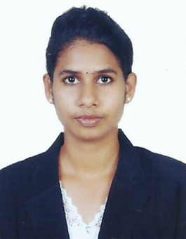

Ammu
Email: ammu.379592@2freemail.com

__________________________________________________________________
CAREER OBJECTIVE
To obtain a position in which I can develop new skills and utilize existing ones in an environment that promotes profesional growth and also to contribute my creativity and hard work towards the success of your company and to the growth of the fast developing field.

Skills
Positive Attitude.
Hardworking.
Willingness to Learn
Provide High Quality supports to clients.
Helps co-workers

ACADEMICS
- Bachelor of Technology in Civil Engineering
University of Kerala Trivandrum, INDIA (2013-2017
- Plus two – Computer science (2011-2013)
- SSLC (2010)
TECHNICAL SKILLS
- Master diploma in Civil Engineering
AUTOCADD 2D, 3DsMAX, REVIT ARCHITECTURE
- PRIMAVERA
- MS Office

SEMINAR
Done a seminar based on the topic superadobe technology it is mainly used in earthquake areas.

PROJECT
We had selected Karimadam slum colony in Trivandrum District, Kerala, India for our Low Cost Township Project .we purposed container homes instead of making Residential buildings and also a cost estimate b/w the two's.Other physical infrastructures are also provided for the projects, that Container homes are economical, cost reductive and eco-friendly to the people.

EXPERIENCE
- Site Supervisor since 2017th July to December, supervision of construction projects under DUA Metals, Kollam, Kerala

INTERNSHIP
  - Completed a eleven days internship at COSTFORD (Centre of Science and Development, Thiruvananthapuram
  - On-going worksites at the slum rehabilitation and slum improvement projects

Personal Details:
DOB : 19-12-1994
Nationality : Indian
Marital Status : Single
Languages known : English, Malayalam, Hindi,tamil
Reference : will be provided upon request

Declaration

I hereby declare that all the details furnished here are true to the best of my knowledge.

