CURRICULUM VITAE
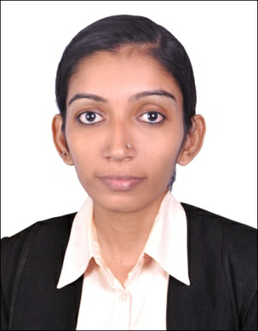
KEERTHI
E-mail : keerthi.379619@2freemail.com

Career Objective

To pursue a challenging career in an organization by sharing responsibilities and applying my skills to achieve the task assigned to me as an individual and to perform in an environment where performance is rewarded with new responsibilities.

Educational Qualification

- MPhil-Computer Science
- MSc. IT

Achievements

- Published a paper in the journal, International Journal of Computer Science Engineering titled ”A comparative study of Energy Efficiency in Wireless Sensor Network”.
- Published a paper in the journal, International Journal of Information Research and Review ”Improved network lifetime maximization in wireless sensor network using ant colony optimization algorithm for energy efficiency”
- Presented a paper in the UGC sponsored National Conference on Computational Intelligence, Practices and Technology conducted at Farook college, Calicut.
- Presented a paper in the International Conference on Competency Building Strategies in Business & Technology for Sustainable Development conducted at Sri Ganesh School of Business Management, Salem.
- Presented a paper in the National Conference on Information & Image Processing conducted at Sankara College of Science and Commerce, Coimbatore.
- Presented a paper in the National Seminar on Cloud Computing and Cloud Security conducted at St.Joseph’s College, Irinjalakuda.
- Participated in National Level Workshop conducted at Kongu Engineering College, Perundhurai.
- Participated in Workshop on MATLAB conducted at SNMV college of Arts and Science, Coimbatore.
- Participated in seminar on Software Testing conducted at Dr.N.G.P. Arts ad Science College, Coimbatore.
- Undergone CORE JAVA course at Dr. N.G.P. Arts and Science College, Coimbatore.
- A certificate of PHP and MySQL training program held at Palakkad.
- Undergone ANDROID course at Dr. N.G.P. Arts and Science College, Coimbatore.
- A certificate for Core Java and Enterprise Training Program held at palakkad.
- Certificate of Computer Teacher Training Course conducted by Academy of Information Technology
- A certificate as the National Service Scheme volunteer.

Work Experience

- From 1st June 2015 to 30th September 2015 worked as a IT teacher in Lakshmi Narayana Vidyanikethan, Palappuram, Ottappalam.
- From 1st November 2015 to 31st March 2016 worked as a Guest Lecturer in the PG Department of Computer Science, NSS College, Ottappalam.
- From 13th July 2016 to 31st March 2017 worked as a Guest Lecturer in the PG Department of Computer Science, NSS College, Ottappalam.
- From 06th November2017 to 01st February 2018 worked as an Assistant Professor in the Department of Computer Science, CCST For Women, Karalmanna.

Languages Known

- English
- Tamil
- Malayalam
- Hindi

Personal Skills

- Good Communication & presentation Skill.
- Decision making
- Ability to work with people diplomatically.
- Complete any kind of work assigned to me with sincerity

Personal Profile

Date of Birth : 04-May-1992
Gender : Female
Marital status : Married
Religion : Hindu
Nationality : Indian

Passport Details

Date of Issue : 05/07/2016
Date of Expiry : 04/07/2026
Place of Issue : Cochin

Declaration

I hereby declare that above mentioned information is correct up to my knowledge and I take the responsibilities for the correctness of the above mentioned particulars.

