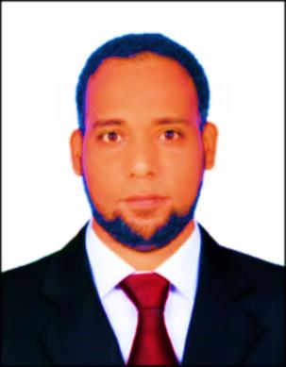
C.V

Kader

Personal Information

E-mail: kader.379629@2freemail.com

Nationality: Egypt

Age: 34 years
Education: Bachelor of Quality Assurance 2001 — 2005 Workers University, Aswan, Higher Ministry of Education (accredited and equivalent)
Skills: Ms. Office, online transactions,
Languages: Arabic (native), English (good)

Experience
2/2/2017- to date: part-time jobs
Service Control:

1/4/2013-1/2/2017: Zahid Tractor and Heavy Machinery, Saudi Arabia, Service Control Department
- Managing and achieving parts sales target according to plan Determine replacement parts required, according to inspections of old parts, customer requests, or customers' descriptions of malfunctions
- Suggesting additional related parts to improve sales
- Handling and providing prices for telephonic enquiries
- Preparing sales orders, invoices and delivering parts
- Managing of receiving payment or obtaining credit authorization
- Advising to the customers on substitution or modification of parts when identical replacements are not available
- Examining returned parts for defects, and ensuring exchange/ refund of defective parts or money
- Conducting inventory of the stock
- Determine replacement parts required, according to inspections of old parts, workshop requests, or workshop' descriptions of malfunctions
- Preparing sales orders, invoices and delivering parts * Examining returned parts for defects, and ensuring exchange/ refund of defective parts

Tourism
- Cataract Hotel 30-12-2012 — 1/10/2007

Supervisor/Service Quality Development / Quality Control / Business Management
More than 5 years of experience in all aspects of restaurant operations, comprised of both front and back of house operations.
Candidate is recognized for consistently delivering and leading others in service excellence through proactively anticipating and responding to guest needs.
Candidate has proven capacity to manage all aspects of business including quality control, purchasing, financial accounting and reporting.

Job responsibilities included:
- Customer Service
- Delivery
- Product & Quality Control
- Purchasing & Inventory
- Staff Scheduling
- F&B Operations
- Regulatory & Safety
- Compliance
- Cost Controls
- Financial Management
- Vendor/Supplier
- Team Leadership
- Waiter/ Host/Expo

Candidate’s strengths in this field included:
- Professional communication,
- service delivery and development and operational management,
- providing high standards of customer service and financial transaction management while sustaining high levels of proficiency in the delivery of services
- Checking and completing financial transactions for other staff members
Recording and monitoring transactions in MICROS system to ensure delivery

- HUHOT MONGOLIAN GRILL
1-10-2005 to1-10-2007
Candidate worked in close collaboration with team members to ensure that customers received high quality of service.
Responsibilities Included:
- taking orders and welcoming and seated guests,
- monitored quality and accuracy of order delivery,
- checking bookings and escorted guest to tables,
- consistently checking requirements and providing response to enquiries.
- presenting menus, explaining menu items and making recommendations
- Serving and clearing food

