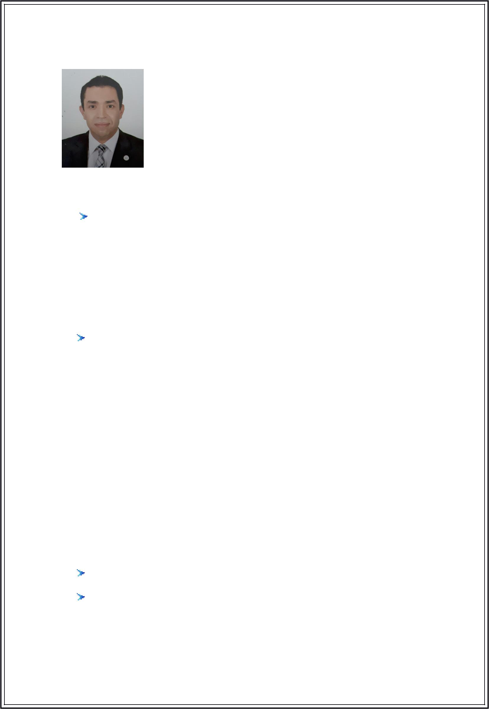
Ahmed

Urology specialist

with DHA license

Nasser Institute hospital

for research and treatment

Experience 9 years

Education: Master (M.B.B.CH.) of urology , Egyptian board fellowship in urology , professional postgraduate diploma in healthcare and hospital management from American university .

DHA 23 marsh 2018

Contact

Name: | Ahmed
_{PERSONAL} ahmed.379637@2freemail.com

_{INFORMATION}

Date of birth : 10-5-1981

SEX: Male

Religion : Muslim

Nationality: Egyptian

Marital status: Married , 3 children

Military service: Exempted

Academic: B.Sc. of medicine and surgery , Zagazig University

Email Address:
Year of graduation: December 2005

Grade: Excellent Driving License : present

Target Job Title: Urologist

Career Level: Specialist

[1]

PERSONAL SUMMARY

A trusted, patient focused and experienced locum doctor with a long history of serving patients by successfully diagnosing, treating and also managing their illnesses and diseases. Easy going by nature and able to get along with other healthcare professionals and also senior managers. Experience of working normal surgery hours and also providing out of hours and weekend cover.

CAREER HISTORY

My Career was started immediately during graduation in the excellent year (8/2007-7/2008) , as a trainer at urology department in ELTAYSEER international private hospital in Zagazig city.

Then my residency was started at Nasser institute hospital for research and treatment (NIH) on 16-8-2008, to start my training , included examination of a high flow of patients in polyclinics and emergency every day , and 24 hours working operations for urology lists and kidney transplantation , by professors from Cairo university (Alkasr ALainy) and Ain Shams university working at NIH.

I have finished my master degree on November 2012 with surgical log book in NIH and a research essay in faculty of medicine at Zagazig university, to work as a urology specialist at NIH.

Then I started Egyptian board fellowship of urology from august 2013 till December 2016 to get my certificate after finishing my 4 assessment dates , surgical log books and Final exams.

Employment Type: Full Time Employee

Working in a busy community surgery providing primary , secondary and tertiary medical care to patients from different communities by way of surgeries, clinics and home visits by:

- Investigating and diagnosing sick and injured patients on their ailments and then arranging appropriate treatments for them.

- Updating and maintaining accurate patient records.

- Advising patients on health education matters.

- Supervising other administrative and junior healthcare staff.

- Learning about the medical history of a patient to ensure they have no allergies etc.

- If necessary referring patients to hospitals or professors` clinics at NIH for further investigation.

- Planning staffing duties and Rota's for medical staff.

- Prescribing medical prescriptions to patients.

- Involved in the day to day running the practice.

- Ensuring a safe work environment for the patients and staff.

- Giving appropriate health education and advice to patients and cares' to enable self management.

[2]

- Ensuring co-ordination and delivery of all work activities within area of responsibility.

- Work in the accident and emergency ward.

- Assessing newly admitted patients.

- Looking after patient under my care who are on wards.

- Working as part of the healthcare team.

- Monitoring and advising medical residents and other junior doctors. My trainers` Recommendation letters are available.

PROFESSIONAL MEDICAL EXPERIENCE (9 YEARS, 8 MONTHS):

- Urology specialist :
August 2008 – present At Nasser Institute Hospital for research and treatment

Job Role: Medical, Healthcare, and Nursing.

Location: Cairo, Egypt.

Company Industry: Government Sector tertiary referral center.

My residency was started at Nasser institute hospital for research and treatment (NIH) on 16-8-2008, to start my training under supervision of professional professors from Cairo university (Alkasr ALainy) and AIN SHAMS university working at NIH.

I have finished my master degree on November 2012 with surgical log book in NIH and research essay in faculty of medicine at Zagazig university, to work as a urology specialist at NIH.

Then I started Egyptian board fellowship of urology from august 2013 till December 2016 to get my certificate after finishing my 4 assessment dates , surgical log books and Final exams.

I got many courses in urology operations, such as open simple surgeries, radical surgeries, transplantation, urethroplasty Hypospadias, andrology, prosthesis, PCNL, ureteroscopy, TURP , endourology and laparoscopy.
Employment Type: FullTime Employee
Working in a busy community surgery providing primary , secondary and tertiary medical care to patients from different communities by way of surgeries, clinics and referral complicated cases.

- Assisted in the operating theaters in surgical operations.

- Master and fellowship surgical log books are available containing more than 300 operation .

  - Delegation In January 2017- present to Dar Elsalam Hospital from Nasser institute hospital as a Urology specialist

Job Role: Medical, Healthcare, and Nursing.

Location: Cairo, Egypt.

Company Industry: Government Sector.

A delegation to the urology department at Dar Elsalam hospital to deal with:

[3]

- Accident and emergency (A&E) with a medical experience.

- Sensitive circumstances sympathetically

- The latest treatments, medicines, surgeries and medical developments up to date.

- Experience of providing care to patients on hospital wards, outpatient clinics and also surgeries.

- Urology operations and decision making .

- Management Responsibility .

- Experience of working in a pressurized environment.

- Complicated cases to be referred to NIH.

- Dar Elsalam surgery log book is available.

• Urology specialist :
June 2015 – present At Rabaa Medical Center , Part Time

Job Role: Medical, Healthcare, and Nursing.

Location: Nasr city , Cairo, Egypt.

Company Industry: Private Sector .

- Having my private clinic 8 hours per week.

- Experience of providing care to patients in outpatient clinic and also surgeries.

- Taking decisions and performing urology operations .

- Organizing medical stuff for pre- and post operative patient care.

- Management Responsibility.

- Experience letter and operated cases are available.

PROFESSIONAL MANAGEMENT EXPERIENCE ( 4 years )

- Assistant manager of Nasser institute hospital for medical tourism. (1-6-2014 till 1-9-2016)

- Medical tourism manager (2"d floor manager) in Nasser institute hospital (NIH) 1-6-2014

- Emergency manager in NIH( from 3-9-2012 till 1-6-2014 )

- Assistant emergency manager( from 1-8-2012 till 3-9-2012 )

In management field I have succeeded in emergency management as an ER Manager since 2012 to 2014 (revolution time) by activation of triage , managing 17 ER beds , control critical times , decrease turnaround time (TAT) in ER from more than an hour to 20 minutes .

By automation of recording system, activation of ER X-ray and U/S inside room , and increasing numbers of ER doctors by getting Egyptian emergency fellowship license to Nasser institute ER department, to be considered as a training center for ER spatiality.

- shared in the developing team sent from ministry of health for El-Zaytoon EL-Takhassosy Hospital , Emergency Unit (5-2-2014), and Luxor international hospital, Emergency Unit (6,7-11-2013).

[4]

I had professional postgraduate diploma in healthcare and hospital management from American university in Cairo (2013-2015) to work on a scientific base.

Ensuring co-ordination and delivery of all work activities within NIH ER department , we had Received and managed many disasters after Egyptian revolution as an Emergency team , including ER manager , assistant managers , professors in all specialties, ER doctors, nurses, paramedical, clinicians and workers and co-ordination with ICU , OR , and Inpatient departments at NIH , under supervision of CEO. (2011-2014).

In June 2014 , I had upgraded to medical tourism manager by CEO - after stabilization of political circumstances – to be succeeded into increase department revenue up to 70% per month by renewal 17 rooms in the department which containing 80 beds, activation of new services and getting new contracts with new customers from different countries .

And By The Soul Of Team work , I had :

- Day to day management of a busy doctors practice surgery.

- The Ability to Set the surgery / practice budget.

- Dealt with patient complaints about the quality of service of the practice.

- Arranged the cleaning, security, and health and safety of the surgery.

- Experience of recruiting resident department doctors , receptionists , public relation, nurses , workers, accounts, and medical records staff.

- The Ability to lead and motivate staff.

- The Ability to prioritize workloads during busy periods.

- Controlled multiple projects at the same time.

And on 1-9-2016 , I had apologize on management career to provide more time for Egyptian fellowship board of urology exam preparation.

ACADEMIC QUALIFICATIONS

- Egyptian fellowship board of urology

(August 2013-December 2016)

At Nasser institute hospital and Alkasr Eleiny.

Location: Cairo, Egypt

I started my Egyptian fellowship board of urology in 2012 at NIH as a training hospital, to be finished after passing exam in December 2016 , under supervision of proffesores from alkasr elainy.
I got many courses in urology operations, such as PCNL, Hypospadias , urethroplasty, TURP and endourology .I have attended many urology conferences in Alkasr Eleiny.

I got my log book with more than 200 operations were done during training course and more than 600 patients examination in outpatient clinic.

- M.B.B.CH. Master of urology

(October 2009-November 2012)
At faculty of medicine in Zagazig university and Nasser institute hospital .

[5]

Location: Zagazig , Cairo, Egypt

Resident of urology department in NIH( from 16-8-2008 till 16-8 2012) , to start my training under supervision of professional professors from cairo university (Alkasr ALainy) and AIN SHAMS university working at NIH.

I have finished my master degree on November 2012 with surgical log book in NIH and research essay in faculty of medicine at Zagazig university, to work as a urology specialist at NIH.

- Professional Postgraduate Diploma In Healthcare And Hospital Management.

From American University in Cairo AUC

(December 2013- June 2015) grade A

Location: Cairo, Egypt

- B.Sc. of medicine and surgery

From faculty of medicine at Zagazig university (September 1999 -October 2005) grade excellent

Location: Zagazig , Egypt.

License Registration

- Dubai health authority (DHA) 23 March 2018.

- Ministry of Health and Population, General Directorate of Medical
Licenses 12 March 2007

ناكسلاو ةحصلا ةرازوب ةيبطلا صيخارتلل ةماعلا ةراإدا م ةنهملا ةلوازم صيخرت

Personal and courses:

1ry & 2ndry Laparoscopic courses ,National Hypospadias work shop ,1st Egyptian international trauma conference , ICRS weapon wounded surgery seminar , National orientation workshop of quality and uses of medical devices and health technology , BLS , ACLS , Patient safety , Quality , filing system .

Skills

- Automation (Expert)
- General Management (Expert)
- Leadership (Expert)

- Microsoft Excel (Intermediate)

• | Microsoft Word (Expert) | Examination | Patient relations
• | Contract Management (Intermediate) | Management_{skills}
- Languages (Expert)

• | Marketing (Expert) | Communication
• | Microsoft Windows (Expert) | skills

[6]

- Recording (Intermediate)

- Languages 5/6english Level: (Expert)

REFERENCES - available on request.

[7]

