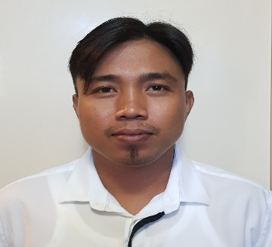

RAFAEL
E-mail Add: rafael.379661@2freemail.com

OBJECTIVE

To work at a responsible and challenging position with an opportunity for professional advancement and growth utilizing my abilities to support and enhance company's goal and objectives.

SPECIAL EXPERTISE
- Takeaway orders packing
- Anticipating and responding to customer needs
- Taking and placing orders
- Friendly disposition to the job. Ability to work under pressure without been stressed
- SMAW /Shielded metal arc welding
WORK EXPERIENCE

Waiter / King Crab House/ January 2003- March 2006

- Escort customers to their tables
- Greet the Customer with smile and introduce yourself
- Prepare and set tables following standard practice
- Present menus to guests and respond to questions concerning menu items, then offer recommendation when asked to
- Find out if customers are enjoying their meals or if they are having issues, resolve any complaint quickly
- Serve the drinks and anticipate the needs of Customer
- Clear tables or counters of dishes and glasses and take them for cleaning at the kitchen.

Checker/Philchinchor Warehouse/ February 2007- December 2013

- When a guest enters my area or department, my first and most important responsibility becomes to acknowledge, greet, and engage that guest.
- Follows daily work schedule as assigned by management.
- Follows dress code in accordance with team member handbook.
- Follows attendance and tardiness guidelines in accordance with team member handbook.
- Performing a range of materials management responsibilities, including vendor relations, order placement, stocking, and maintenance.
- Evaluating inbound and outgoing product shipments to ensure quality control and accuracy.
- Excelling in both independent and team-oriented environments and roles.
- Performs other duties as requested or required by management.

WELDER / K.A.J WELDNG SERVICES – January 2014 to February 2018
Repairing of Barges and Tanker at Shipyard

- Create quality welds according to blueprints (weld symbols).
- Inspect welds for accuracy.
- Prepare product to be welded by grinding and cutting steel parts.
- Responsible for the proper packaging, identifying and moving of all finished products to the proper location.
- Ensure all equipment is properly set-up and used in a safe manner and that all safety devices are in use.
- Performs first piece inspections as well as all subsequent inspections as required by RMF standards.
- Monitor equipment and request maintenance when required.
- Perform simple maintenance and repair as required

EDUCATION

ELEMENTARY

1991-1996
SOUTH ELEMENTARY SCHOOL GAPAN CITY

1996-2000
Juan R Liwag Memorial High School

Personal Information
Birth date : September 02,1984
Birth Place : Lucban, Quezon Phil.
Nationality : Filipino
Sex : Male
Hobbies : Browsing the internet and Playing Basketball

Passport Details
Issued Date : February 15, 2014
Expiry Date : February 14, 2019

