MIRZA Mirza
Computer Engineer

Objective
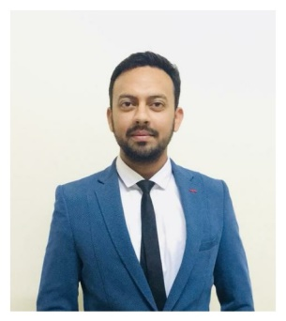

Email: mirza.379666@2freemail.com

I would like to secure a position where my skills and professional attitude will be an asset to the employer and an enhancement platform for my current experience.

Education

- Degree: B.Tech in Computer Science & Engineering
- College: AKTU, India
- Date of completion: 2017

experience

- Graphic Analyst/Tester (From 2014 – To 2016)
(As a freelancer)

I have an experience of handling different projects at the same time and accomplishing them before the due date. Had responsibilities to cover updifferent positions in the absence of my colleagues. Worked over 100 days in character designing using blender software with the successful output.

TECHNICAL EXPERTISE

PHP

Java

Python

C++

HTML

JavaScript

CSS

Dreamweaver, phpstorm

Animation/Graphics

Certificates

- Certified in HTML programming,
- CSS
- C++

extra curricular activities

- Attended technical workshop Ethical Hacking at Galgotia College of Engineering, Noida.
- Participated actively in sky observation seminar held at Amity University, New Delhi.
- Participated in WIZKID-20** under Expert Group.

personal details

- Date Of Birth : 09.12.1992
- Languages Known : Hindi, English, Urdu
- Marital Status: Single.

I hereby declare that all information provided above is as per best of my knowledge.

