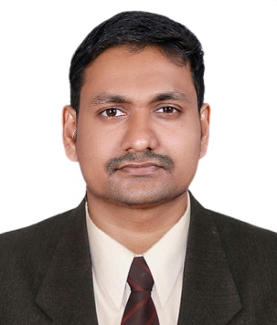

DEEPU
 deepu.379670@2freemail.com

PROFILE
I’m an adaptable and innovative qualified Mechanical Engineer with over 3 years of experience in product design and development, project management, and quality assurance. Skilled in inspection, welding techniques and document handling with a strong understanding of engineering mechanics, principles, and materials. Seeking a challenging and professional environment, where I could make significant contribution towards the growth of the company.

PROFESSIONAL EXPERIENCE
- NATIONAL ENGINEERING INSTITUTE (June 2017 to March 2018)
As a mechanical instructor, my responsibilities include
Giving professional training for the candidates with different types of welding equipment like Arc welding, oxy acetylene welding, mig welding, tig welding, central ac system, HVAC and MEP systems. Conduct weekly evaluation and preparing the performance report for the candidates. Submit monthly report to the superiors via internal mail system.
- OLIVER VALVES INDIA Pvt Ltd, COIMBATORE (June 2016 to May 2017)
As a mechanical engineer, my responsibilities include
Inspecting, repairing and maintaining a variety of valves include Gate Valve, Butterfly Valve and Globe Valve. Preparing and maintaining documents related to the inspection and repairing of the valves.
Check Quality of the finished products before its dispatch according to the pre-prepared checklist.
Apply new standards for the quality inspection as the feedback from the customers.
- EVERON CASTINGS Pvt Ltd, COIMBATORE, INDIA (July 2011 to April 2013)
As a Component In charge cum Quality instructor, my responsibilities include
- Responsible for the quantity that processed completely in Out Sourcing with nearly of 10 operations
- Responsible for solving customer problems and giving satisfied information about products.
- Responsible for solving customer problems and giving detailed information about products.
- Apply new quantity management techniques to reorganize dispatch plan.
- Checking the quality of casting by Non Destructive Testing (MT, UT, RT, PT)

SPECIAL EXPERIENCE:
  - HMT Ltd, kalamassery.
- Familiarize with industrial environment.
- Study various operations and machines.
- Study the preparation of various Documents.

ACADEMIC QUALIFICATION
- BE in Mechanical Engineering, Mar Athanasius College Of Engineering – June 2016
- Diploma In Mechanical Engineering, Kerala Technical Board – April 2011
- Higher Secondary Education, Board Of Kerala HSE – March 2008
- Matriculation, Board Of Secondary School Education, Kerala –March 2006

ADDITIONAL QUALIFICATION
- NDT Level II (RT, UT, MT and PT)
- Process Piping Design & Engineering as per ASME B-31.3

IT SKILLS
Operating System : Windows 10, OS X, LINUX
Packages : MS Office, Adobe CC
Software known : Auto cad 2D &3D, Creo, Solidworks

PERSONAL DETAILS
Age & Date of Birth : 27Yrs, 03-03-1991
Sex : Male
Marital status : Single
Linguistic Abilities : English, Hindi, Malayalam, Tamil
Nationality : Indian

