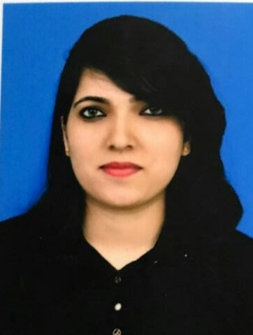
NEETHA

Neetha.379695@2freemail.com

OBJECTIVE

To seek a responsible career in the field of Human Resource/Administration where I can utilize my skill and knowledge, which demand practical and endless creativity. Looking forward to add valuable experience and new direction and challenge in all areas of Human Resources by continuously using both theoretical and practical background in new areas.
EDUCATION
Particulars | Institution | Year
Computer Accounts | Institute Of Computer |  | Passed in Dec 2012 with Grade B
 | Accounts, Mangalore | 2012
Bachelor of  Commerce | Vijaya College,  Mangalore University | 2012 | Qualified in June 2012 with 62.54%
[B.com]
 | Vijaya College |  | Qualified in March 2009 with 51.5%
PUC | Mangalore University | 2009
Medaline Convent Qualified in March 2007 with 53.28%
SSLC Mangalore University 2007

SUMMARY OF EXPERIENCE

I am an experienced Admin Assistant who has, in the past Three and a half years, accumulated service relevant experience in Tamimi Group [Doha Qatar] in the core areas of strict compliance with all of the company’s administration policies, procedures and ways of working, Supporting the overall team with administration, Establish and implement administrative policies and procedures for the office, Coordinating agendas for meetings with visitors and clients– arranged guest and travel accommodations.

Prior to Tamimi I had gathered ample of experience in the administration/accounting filed over one year in AJ HOSPTAL & RESEARCH CENTRE (Mangalore, India). The majority of the experience is from providing billing information by collecting, analyzing, and summarizing third-party billings, accounts pending, and late charges data and trends.

 |  |  | From, May-2014
Tamimi Group | Admin Assistant | Doha, Qatar | Dec-2017

I had been an Admin Assistant over 3.7 years with Tamimi Group worked for liaison organizational staff, executives, clients, vendors and visitors on a daily basis, vendor management, broadly, my responsibilities entail:

- Maintained the office database – retrieved and organized information for individual employees and clients
- Sorting and distributing incoming communication data, including faxes, letters and emails
- Performed various secretarial/clerical duties such as documenting, faxing, mailing, & organizing filing system.
- Supervising and recording corporate documentation, electronic files, inventories and reports.
- Supporting the overall team with administration duties including minute taking, online research & data entry
- Arranging the travel and itineraries for senior office personnel such as booking hotels and transport. Scheduling meetings and preparing agendas for them
- Undertaking billing work, managing diaries, typing up correspondence, documents, minutes and reports
- Providing training and orientation for new staff
- Scheduling and delegating administrative tasks
- Comprehensive knowledge of Microsoft Word, Outlook, Excel and Access.

- Resolving administrative problems.
AJ HOSPTAL & RESEARCH CENTRE | India | From, Jan 2013 -
 |  | Jan 2014

- Determines patient invoice by capturing services noted in patient chart, clarifying services with physicians.
- Identifies responsible party by examining patient record.
- Issues invoice by entering service data, calculating charges, mailing invoices.
- Resolves billing issues by discussing contract with third-party payer, explaining insurance contract with patient, negotiating settlement.
- Maintains patient and invoice files by entering data.
- Provides billing information by collecting, analyzing, and summarizing third-party billings, accounts pending, and late charges data and trends.
- Updates job knowledge by participating in educational opportunities.
- Accomplishes medical office mission by completing related results as needed.

PERSONAL DETAILS |  |  | PROFESSIONAL COUSES & ACHIEVEMENTS |  |  |  | IT PROFICIENCY
Date of | July 01st , |  | Attend National Cadet Crop Level one |  | Proficient in MS Office application, Particularly MS Word & MS Excel, Outlook. In MS
Birth: |  |  | Examination Conducted by Udupi District,
 | 1991 |  | Mangalore, India
Nationality: | Indian
Languages: | English
 | Hindi
 | Kannada and
 | Konkani
Marital
Status: | Married

References: Will be furnished upon Request

Availability: immediately

Declaration

I hereby declare that the above said details are true to the best of my Knowledge and belief.

