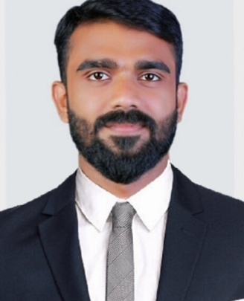
RESUME

TIBIN
Email: tibin.379699@2freemail.com

Personal Profile
To serve in an esteemed organization in a dynamically stimulating and challenging environment to add value to the company’s reputation and further develop my potential to its optimum.

Work Experience
- Two year experience as an Assistant Accountant at Royal Goan Beach ResortPvt.Ltd. Kerala, India.Working since 01/01/2014 to Dec 2015.
- One year experience as a Cashier /Salesman at Al Moski Trading llc.Sharjah, From 15/ 01/ 2017 to 08/01/2018
Accounts:
- Expertise in TALLY ERP9 for the all the modules such as Accounts Payable, Accounts Receivable, Cash Management, General Ledger and Inventory Modules
- Beginner in preparing monthly financials like Trial Balance, Profit & Loss a/c, Balance Sheet, Cash Flow statement.
- Beginner in Audit preparation of yearly financials in audit format and submitting to auditors for auditing
- Experienced in preparation of monthly Bank Reconciliation statement
- preparation of debtors & Creditors Outstanding list and reporting to Management. Expertise in reconciliation of receivable & payables with their respective statements Supervising and Coordinating subordinates to ensure in smooth accounting.
- Diplomatic and Excellent in Public Relation and Office Administration
Audit:
- Vouching of Cash and Bank Books, Sale and Purchase Register, Debtors Ledger, Creditors Ledger, General Ledger so as to authenticate the figures appearing in the Books of Accounts of the client. Verification of Banks Reconciliation Statements, Fixed Assets and Stock

Human Resource:
- Recruiting job seekers as per the requisition of various depts.
- Training
- Define job description of Employees
- Leave management
- Employee welfare norms
- Performance appraisal
- Employees transfer, promotions and terminations.
- HRIS to Management
Manage:
- Stores & sales team
- Lead & supervise
Technical Skills

- Tally ERP.9
- M S Office
- Internet and Email
- DTP
- WEB Designing

Educational Qualifications
- COMPANY SECRETARYSHIP- Institute of company secretaries of India Pass foundation – and (doing Executive program)

- B.COM (TAXATION) - Mahatma Gandhi University, Kottayam, Kerala.

- HIGHER SECONDARY - Board Of Higher Secondary Examination

- SSLC - Board of Education Govt. OF Kerala

Profile
 | Date of Birth |  | : 27 Yrs, 12 Nov 1991
 | Religion & Caste |  | : Islam, Muslim
 | Sex |  | : Male
 | Marital Status |  | : Single
 | Nationality |  | : Indian
 | Languages Known |  | : English Malayalam, Tamil, Hindi, Arabic

DECLARATION:
I, hereby declare that the information furnished above is true to the best of my knowledge and belief.

