C V

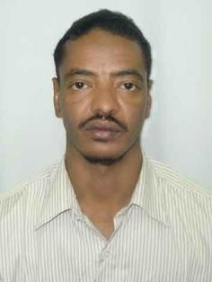Name / Mudather

E-mail mudather.379718@2freemail.com

Date of birth 7/6/1978 Religion
Muslim

Nationality Sudan Marital status married

Graduation date 26/2/2006

Qualification MBBSIN MEDICIN AND SURGERY

LICENSE : Permanent certificate of registration of Sudan medical council

Occupational classification of the Saudi commission for medical specialties as GP

MOH UAE Evaluation certificate DHA eligibility litter

Professional experience:

1) GULFS COUNTRY EXPERIENCE (from13/10/2010 up to now) GP doctor in SAUDI ARABIA from 13/10/2010
Work in Al-Thagar general hospital in Saudi Arabia from
12/5/2015 IN ER DEPARTMENT up o now

2) Other experience Franchise doctor from Sudan ministry of health from 10/4/2007 to 9/8/2008

GP doctor in Sudan MOH From 25/8/2008 to 30/8/2010 in
Eldamer general hospital in ER

WORK at pediatric department in Eladamer hospital

Work for few months in GS in Edamer hospital for few month

Skill Arabic as mother tongue English
Computer skill

Course attended family medicine BLS COURSE

