CURRICULUM VITAE
KRISHNA.
Email : krishna379721@2freemail.com

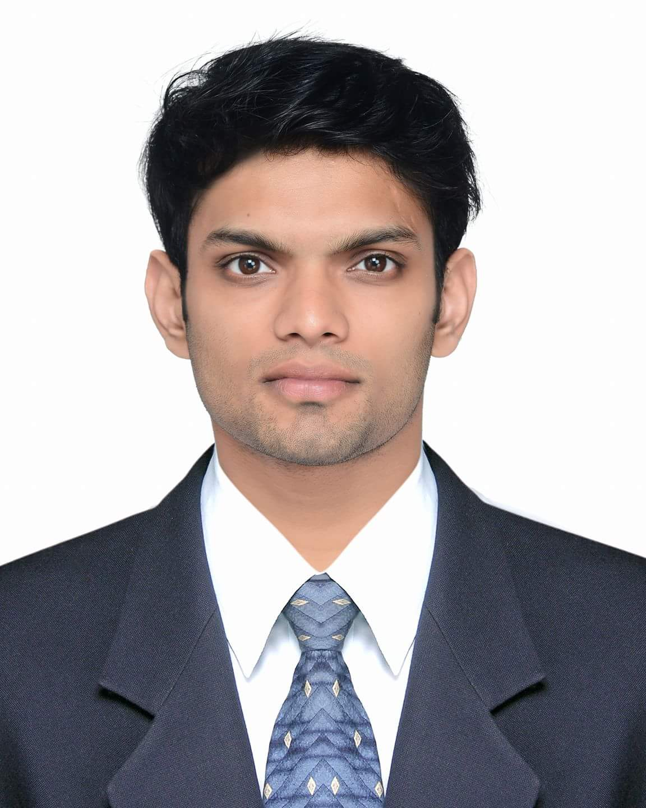

PERSONAL PROFILE

Date of Birth : 12/02/1990
Nationality : Indian
Marital Status : Single
Sex : Male

LANGUAGE PROFICIENCY

Fluent in English & Malayalam

VISA STATUS

Visit Visa

DRIVING LICENSE

Valid Indian Driving License Holder

CAREER OBJECTIVE

To acquire a good job in a Company I like so that I can effectively utilize my potential and skills in best possible manner and to work as a team for the growth of the Company.

- B.Tech in Electronics and Instrumentation Engineering, Amrita School of Engineering, Amrita Vishwa Vidyapeetham University, Coimbatore, Tamil Nadu (2009 - 2013)

CGPA : 5.79

12th, Don Bosco Higher Secondary School, Mannuthy, Thrissur, Kerala (2008)

Aggregate : 91.3%
- 10th, Hari Sri Vidya Nidhi School, Thrissur, Kerala (2006)
Aggregate : 78% (ICSE)

- Technical Support Representative - Pole To Win, Bangalore (November, 2016 - November, 2017)
- Contract job as Consultant - Myntra, Bangalore (June, 2016 - August, 2016)
- Sales and Customer Service, Admin - Selections textiles and readymades, Thrissur (2013 - 2016)

- In-plant training at FLUID CONTROL RESEARCH INSTITUTE (FCRI), Palakad

INDUSTRIAL EXPERIENCE

EXPERIENCE

EDUCATION

`
PROJECT

- Mini Project (Nov 2011)
Title: DIGITAL TEMPERATURE METER, Amrita School of Engineering , Coimbatore

- Major Project (May 2013)
Title: AUTO PARK ASSIST , Amrita School of Engineering, Coimbatore

TECHNICAL SKILLS

- C, C++, Proficiency in M.S Office, Basics in CAD, Adobe Photoshop
- Participated in Automobile technologies workshop held at NIT, Calicut
- Participated in Ethical Hacking and Cyber Forensics workshop during Techfest (ANOKHA 2012) at Amrita School of Engineering, Coimbatore

KEY SKILLS

- Good communication and Interpersonal skills
- Ability to work under pressure
- Good time management skills
- Creativity in solving problems
- High commitment in team work

ACHIEVEMENTS

- Have participated in various athletics events and won many prizes
- Overall Champion in Yoga competition, Won prizes for Weight lifting competition and Photoshop contest conducted at Amrita School of Engineering, Coimbatore
- Participated in Shooting Championship conducted by Thrissur District Rifle Association
HOBBIES & INTERESTS

- Cars
- Aviation
- Swimming
- Yoga
- Listening to music
DECLARATION

I do hereby declare that the information stated above is true to the best of my knowledge.

Thanking You

Yours faithfully,
KRISHNA

