Halith  Email: halith.379752@2freemail.com  Visa Status : Visit Visa | 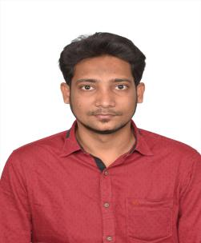

Seeking a Challenging Position involving analysis, design and development of projects in an environment where I can grow along with the organization with greater responsibility

Educational qualification

- Bachelor of Engineering(Mechanical) at Anna University completed on 2016 with 66 %
- HSC at Al – Ameen Matriculation Higher Secondary School completed on 2012 with 65 %
- SSLC at Al – Ameen Matriculation Higher Secondary School completed on 2010 with 69 %

Technical proficiency

- Design Software : AUTOCAD, SOLIDWORKS, CATIA
- Computer Skills : DCA, Operating System Windows XP/7/8/10

Professional experience and designation

- Designation : Graduate Engineer Trainee
- Company : CADD School Pvt Ltd
- Duration : 28th Feb 2017 – 31st Aug 2017

Career performance

- Training Undergone
  - Prepared comprehensive drawings referring to available notes and sketches in AutoCAD and SolidWorks.
  - prepared hand drawn sketches and measured accessible equipment.
  - Developed detailed drawing for layout of existing equipment.
  - Inspected all designs for accuracy comprising of part dimension and connect of all parts with one another in entire structure.
  - Developed components as well as assembly models.
  - Printed all fabrication related drawings.
  - Provided drawing and design assistance to senior draftsman.

Certifications

- Diploma in Mechanical CAD
  - AutoCAD
  - SOLIDWORKS
  - CATIA V5

Mini project

- Project Area : Manufacturing Technology
- Title : Design and Fabrication of Pedal Operated Screw Jack

Final year project

- Project Area : Performance Analysis
- Title : Performance and Emission Characteristics of CI Engine using Diesel with Aluminium
Oxide Nanoparticles as addictive

Competencies

- Fast Learner and Hardworking
- Team worker with ability to lead
- Commitment towards work, Sincerity and Self-confidence
- Honest, Sincere with high level of integrity

Personal vitae

- Date of Birth : 30/07/1994
- Nationality : Indian
- Gender : Male
- Martial Status : Single
- Languages Known : English, Tamil, Malayalam, Hindi

Declaration

I hereby declare that, all the above information provided is true and to the best of my Knowledge.

