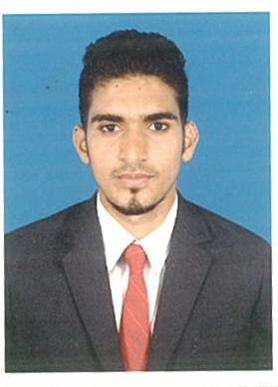
RESUME

- Personal Information:-

- IRSHAD
- C/o-Mob:+971 5016785421
- Email – irshad.379819@2freemail.com

2) Educational Qualification
Degree | Institute
SSLC | Karnataka State Board
P.U.C | Department of Pre University
B.com | Mangalore University

3) IT SKILLS
- Proficiency in Computer Skill such as MS Office XL, word and Tally 9
4) Other Skill
- Highly trustworthy, Hardworking and Flexible to working hours
- Excellent Interpersonal & communication skills, Quick learner
5) Work Experience:-
1 Year work Experience Accounts Executive/Cashier/Data Controller with Q BABY:
- Preparing the Voucher.
- Preparing Reconciling Daily Activity Report
- Handling petty cash
- Handling Proper Filing, documentation.
- Verifying expenses & Issuing Petty cash as per requirement.
- Preparation of weekly and monthly reports on outstanding bills.
- Reconciliation of the company Ledger with the bank account
- Checking Suppliers & Sub- contractor bills.
- Monitoring and Controlling of Debtors & Creditor.
- Filling of VAT return and related VAT reports and requirments

6) Hobbies
- Playing Cricket,

7) PERSONAL DETAILS:

Gender : Male

Date of birth : 27/07/1994

Marital status : Single

Nationality : Indian

Religion : Muslim

Language known : English, Hindi, Kannada, Malayalam

VISA : VISIT VISA

Declaration :
I hereby declare that the information furnished above is true to the best of my knowledge.

