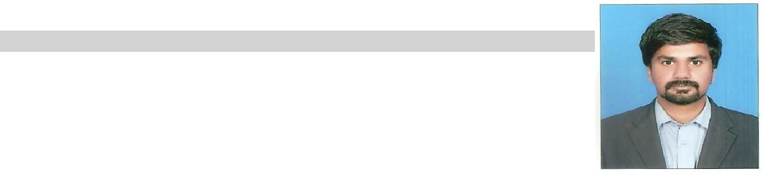
Raja

Personal Information

Date of Birth: 05-07-1992

Nationality: Pakistani

Email: raja.379892@2freemqail.com

Academic Education

Bachelors of Buisness & Administration BBA (Hons); 4-years degree; Major: Marketing
Global Institute, Lahore (A Chartered University)

Intermediate with Computer Science; Major Subjects: Mathematics, Physics, Computer Science
Govt. College for boys, Gulberg , Lahore

Matriculation (High School); Major: Physics, Chemistry, Biology , Mathematics
St, Anthony's High School, 3-Lawrence Road, Lahore.

Technical Chef Training (9 months); Major Dishes: Asian Food, Chinese Food, etc
College of tourism and hotel management Lahore (COTHM)

Projects

- Principles of Marketing (Launching a new restaurant)
- Principles of Management (on McDonald)
- Focus group (Food inspector & members to main good quality)

Professional Experience & Internship

2017(July to January)
Working at Harvest global market as a Business development executive

- Address and resolve customers issues, utilizing effective listening and problem solving skills

- Giving presentations to the clients about the business plans in commodities and currencies
- Grow business revenue by making new clients

- Calls customers and let them know about business plans about investments
- Buying and selling of commodities and currencies on customers behalf

2016/17 (September to April)
Worked as Sales executive at Ibex Global (TRG Company)

- Inbound campaign from USA for different service providers for internet, cable telephone and home security

- Assist the prospective and existing customers and use our strong communication skills to sale products to the customers

- Generate revenues for the company by soliciting and obtaining orders and ensure that all customers accounts are developed according to company protocols

2016 (May to July)

- Internship in Shaukat Khanum Memorial Cancer Hospital in Marketing Department.
- Call the existing donors and recall them to keep on donating to the hospital
- To grow the donation for the hospital by engaging with different banks and restaurants
- To get involve in different marketing campaigns for fundraising and sale charity tickets

2012/15 (November to October )

Worked as Customer support executive in Ibrama Communications

- Make outbound calls to prospective and existing customer to provide them with information on new products, discounts and services

- Deliver prepared scripts regarding a service or product, building up on the information as the conversation progresses

2012 (Feb - August)

Worked as Marketing Executive in Racket Benkizzer Company

- Meet and surpass daily productivity goals.

- Strategically get involved in the development of products and services, defining targets, budgets and goals and initiate new marketing procedures and policies to enhance customers experience within the retail establishments.

- To plan and implement marketing mix activities according to approved brand strategy, including promotional programs, marketing research projects, and advertising activities

Additional skills and hobbies

- Microsoft Office (Excel, Word, Power point)

- Volunteer Youth Committee Member and Program Organizer
- Music, travelling, etc

- Sports, Basket Ball, Football, Cricket

Extra Curricular Activities

- Team Member, Cricket & Football (St, Anthony's High School)

Reference/s

Will be furnished on request

