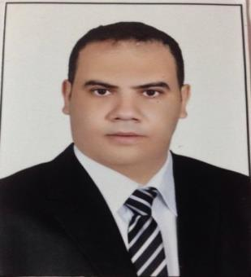

Osama

Osama.379904@2freemail.com

Egyptian, 1may 1985

Current location : El Nahda Dubai .UAE

Bachelor of pharmaceutical sciences Tanta University 2007 (very good)

Diploma of clinical pharmacy Tanta university 2015(very good)

Pharma D (Doctor of Pharma Degree in clinical pharmacy) Mansoura University 2018(

Very good)

DHA eligibility letter

- Retail pharmacist, pharmacy manager in Dr Osama Mohamed pharmacy (own licenced pharmacy) 2016:2018

- Clinical pharmacist in Alexandria Fever Hospital (GIT, and Hepatology department) and Alexandria University Hospital (Oncology department) 2015:2016

3. Hospital pharmacist in Qotor hospital, Ministry of Health, Egypt 2014:2015

- Retail pharmacist in GNC ARMAL KSA(General Nutrition Centers) Saudi Arabia, 2011:2013

- Retail pharmacist in Tadawi Health Care Company in Saudi Arabia 2009 to 2011

- Retail pharmacist from graduation in DR Osama Mohamed pharmacy in Egypt 2007 to 2009

- Excellent Knowledge of Microsoft Windows ,Word, Excel, Power Point, Access, Internet, Database )with ICDL certificate, certificate from health IT and statistical training center (ministry of health ), certificate from ( ISC Tanta university )

- Very Good command of both written and spoken English, Passed English language exam of Tofel with certificate from Ain Shams university

- Native language Arabic.

4. Little command of both written and spoken French

- Clinical pharmacy skills. Studied full pharmacotherapy course as a part of American board of pharmacotherapy specialty

- Residency for one year in clinical pharmacy Egyptian fellowship. Registered as a clinical pharmacist specialist at Egyptian Pharmacist Syndicate

- Clinical pharmacy Training program in Mansoura university for a year in Mansoura university hospitals(oncology cardiology – diabetes -intensive care department) as a part of pharm D degree

- Dispensing medicines skills :dispense medicine accurately in line with prescriptions and approved insurance claims to the patient whilst ensuing minimum waiting time for the patient

- Educate patient and patient family how to take the medication

- Stock and items expiry management

- Chemotherapeutic drugs preparation and TPN preparations

- Work as apart of healthcare team, to reach to the best medication plan

- Evidence based medicine with medication error inspection

10. Monitor doses of drugs and dosage form and ensure correct drug for correct patient at correct time at correct dose for correct duration

11. Customer services : supervise the staff and be sure they are in excellent level; of customer services

12. Saudi Heart Association Cardio Pulmonary Resustion Certificate

13. Active, Motivated and Ambitious., work as a cooperative team member with excellent communication skills, Work under pressure, Flexible to work in shifts,

14. Driving skills with license from Egypt and Saudi Arabia

