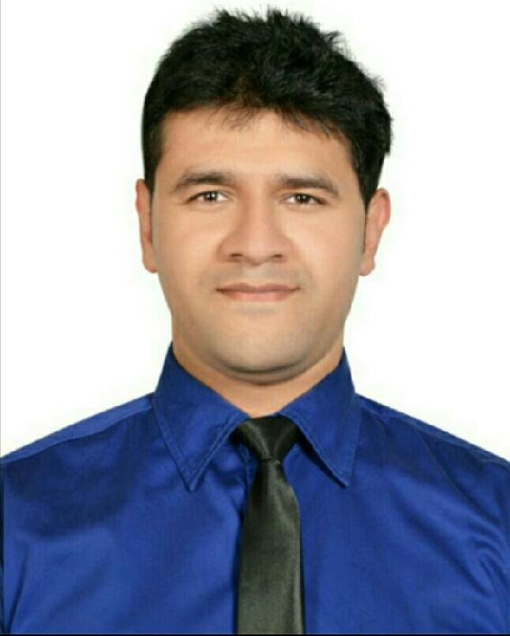

Abhijeet.379948@2freemail.com

ABHIJEET

Profession : STORE MANAGER

Born : 05/Oct/1984
Nationality : INDIAN

OBJECTIVE :

A Creative Position where management and technical skills are required, preferably "STORE MANAGER"

STRENGTH :

I Have over "10 YEARS" RETAIL EXPERIENCE in Dubai & I also have PIC (Person-in-Charge) Certificate for Dubai Muncipality
- a PERFECT ALL ROUNDER ¤ a Energetic and Strong team player
- Always Polite and helpful ¤ Possessing plenty of patience
- Trustworthy, hardworking, fast learner & Reliable ¤ Physically fit
- Ability to work under pressure ¤ Having plenty of stamina and able to stand for long periods ¤ Assisting Shoppers to find what they are looking for ¤ Arrange any home deliveries that customer required

- Check shelves and replenish supplies of any products that are running low ¤ Control inventory input procedures (Item creation, Price update, GRV, Stock adjustment) ¤ Check Rental Gondolas as per Supplier Agreement ¤ Check Order forms and Generate LPO's according to the suppliers ¤ Handling Customer Complaints in a claim manner

- Monitoring and process Daily Cash collection payments to the Designated Bank or with the Accounts department as well as Debit or Credit Card transactions in accordance with company procedures and policies as per their system ¤ Prepare the displays and ensure that they remain in good condition throughout the promotional period

- Making sure the shop looks Good and is ready for the day's trading

- Can work independently ¤ Multi-task and take ownership of various parts of a project or initiative ¤ Creating Eye catching & dazzling shop displays ¤ Compose a program for Customers attraction like flyers or promotion paper and publication ¤ Willing to work irregular hours to cover busy periods ¤ Follow FIFO (First in first out) method and streamline overall delivery system to various branches without affecting day to day operation of retail branches ¤ Monitoring of products and vendors' activities - Team management and ensures compliance of employees with security, hygiene, sales, and record keeping ¤ Always positive, even under difficult circumstances

- Always willing to help others to achieve the team's goals
- Capable to Work on Rotational shifts & on Weekends aswell.

SKILLS :
- Deep PRODUCT KNOWLEDGE of all Brands & Grocery products
- High Proficiency in COMPUTER SKILLS (Tally ERP 9, Microsoft Excel, Powerpoint) ¤ Strong negotiation, communication and leadership skills

- Fluent English and Good Communication both written and oral
- Directing and guiding junior staff ¤ Capable for analyzing and solving problems ¤ Doing work with timely manner ¤ Responsible for all the tasks assigned ¤ Strong Leadership and Organizational skills.

• Languages known : ENGLISH ¤ HINDI ¤ URDU ¤ SINDHI ¤ ARABIC.

This resume is made with Free Resume App

~ Experience ~ | Current Designation :
 | Store Manager
 | WEST ZONE GROUP
 | 2013 - 2017
 | I have more than "4 YEARS" Experience as a
 | SUPERMARKET MANAGER in one of Dubai's leading Local
 | Supermarket chains WEST ZONE GROUP in
 | AL KARAMA & AL MIZHAR BRANCH Dubai (U.A.E)

Past Designations :

Asst. Manager, Field Supervisor, Customer Service Executive, Head Cashier, Store Keeper, Stocker & Cashier.
AL MAYA GROUP

2007 - 2013 (Six Years)

I Worked as a STOCKER, CASHIER & as a

CUSTOMER SERVICE EXECUTIVE in
AL AIN CITY CENTER (AL AIN)
Year 2007 - 2009

I Worked as a STORE KEEPER & FIELD SUPERVISOR in AL MAYA SUPERMARKET
(DUBAI MARINA & DAILY GOURMET J.B.R BRANCH)
Year 2009 - 2011

I also have a Experience as a ASST. MANAGER & HEAD CASHIER in JESCO AL MAYA SUPERMARKET (AL BARAHA, DEIRA BRANCH)
Year 2011 - 2013

Own Business
WALK LINE SHOES
(Exclusive Range of Kids Footwear)

1997 - 2006

As a OWNER ~ I Run a SHOE SHOP

for 9 Years in City - Indore (M.P) INDIA

This resume is made with Free Resume App

~ Education ~ _{School}

- ~ ~ ~ If I talk about my Studies, I have done my Schooling from

EMERALD HEIGHTS INTERNATIONAL SCHOOL

1990 - 2002

College
~ ~ ~ ~ ~ If I talk about my Qualification, I have done B.COM
I Completed my Graduation from
RENAISSANCE COLLEGE OF COMMERCE,
MANAGEMENT & SCIENCE.

2002 - 2006

~ Hobbies ~

- Most of my Spare time in the evening or weekend is takenup and Socializing with my Close Friends or doing activities that i enjoy such as Hanging out and Watching Movies with Friends ¤ Improving my Arabic Language

- Jogging ¤ Team Sports or Games like Cricket and Football are a favourite past time of mine as they give me a chance to meet new people and make friends.

~ REFERENCE ~ :

¤ Available on Request.

~ SALARY EXPECTATION ~ :

¤ To be discussed during Interview.

- UAE DRIVING LICENCE ~ : ¤ Going to Apply Soon.

- DECLARATION ~ :

- I here by declare that the above furnished information is authentic to the best of my knowledge.

Please find attached a copy of my CV for your consideration. I am an excellent candidate for this vacancy as it closely matches my skills and experience. I look forward to hearing from you.

This resume is made with Free Resume App

