NIBU  Email: nibu.380044@2freemail.com |  | 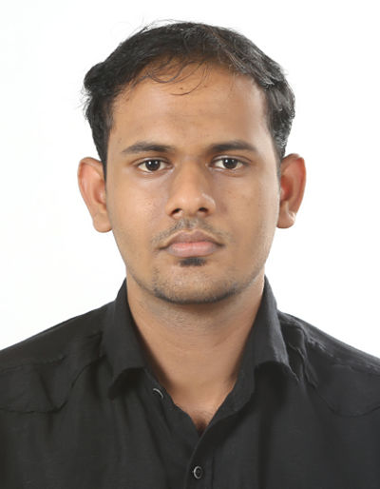
To work in a challenging and dynamic environment, which gives me an opportunity to add value to the company and enhance my knowledge and continuous development of upgrading knowledge by execution of vested responsibilities by the organization with loyalty and integrity

CURRICULAM VITAE
PROFESSION: System/Office Administrator (Software Support)

An IT Profession and Office Administration with more than 2 Years’ experience in reputed organizations in India. Skilled Software Analyst experienced in monitoring, maintaining, improving and upgrading systems and applications. Performed office administrative tasks such as Managed daily office operations, planning and coordinating meetings, handling office mails. Developing social media and content strategies for Digital marketing.

PROFILE SUMMARY
- Maintain and manage all software systems
- Following standardized company procedures relating to all aspects of Office performance
- Configuring and managing backup
- Provided training to End-users and customers
- Drafting Documents and letters
- Good communication skill with good command over written and spoken English
- Excellent in Troubleshooting and problem solving
- Managing and developing Digital marketing through internet
- Arranging interviews and confirming interviews by email.
- Payroll Management and HRMS

ACADEMIC QUALIFICATIONS:

- Post-Graduation-MSc IT-Sikkim manipal University-India
- Graduation – 2013-BSc computer Science-MG University-Kerala-India
- Pre-graduation – 2010 – Board of higher secondary examination – Kerala –India
- Matriculation – 2008 – Board of Public Examination- Kerala-India

WORK EXPERIENCE:

Name of the organization | Designation | Duration of work
St: Thomas Hospital | System Admin | October 2016 to October 2017
Shalimar Marbles and Granites | IT/Office Admin | July 2015 to August 2016
AREAS OF EXPOSURE

- Coordinating with Accounts department for reducing their work load
- Analyse application data to assess performance and uncover problems
- Troubleshoot and resolved application issues escalated from end users.
- Managing documentation accordingly to requirements and standards
- Prepare reports and presentations for internal communications & analysis
- Ensure data security, including directory, group policy, firewalls, antivirus, email security and access control
- Protect the data from cyber threats/malware/viruses evolving email and web threats.
- Responsible for Employee Attendance machines and payroll management
- Managing HRMS
- Provide for the installation, configuration and support of computer software’s and devices
- Expand company social media presence in existing all social medias and Management of our Google account for display adds, web keywords for web search performance
- Expertise in the use of MS office tools namely like Word, Excel, Access, Power Point, Outlook and Google sheets
TECHNICAL SKILLS

Language :SQL, Basics of C, C++ and Java
Applications : Client Server Applications
OS Platform : All Windows Version and Linux
Database : Installing configuring Oracle and Microsoft SQL Server
: Supporting Database and monitoring
Healthcare information technology : Supporting Hospital Information system

PERSONAL DETAILS:

Nationality : Indian
Marital Status : Single
Current location : Dubai
Language Known : English, Hindi and Malayalam

DECLARATION:

I hereby declare that the above mentioned information is true to the best of my knowledge and submit my resume of your kind observation and favourable order

NIBU

