SIVAPRASAD  Email id : sivaprasad.380055@2freemail.com | 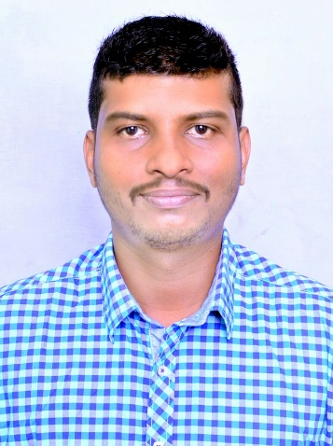

Career Objective:To be part of a company that provides a challenging and rewarding career while allowing me to utilize my knowledge and skills and to obtain a respectable position with a global business, or professional associations that is seeking individual who can analyze, organize, and manage challenging projects that promotes growth.

Strengths:
Ability to work with minimal supervision
Good team player and multitasking skills
Decision making skills and good communication skills
Flexibility and adaptability
Fast learner and dedicated in delivering team success
Language skills in English, Hindi, Malayalam and Tamil
Creating a positive work environment

ProfessionalExperience:

Aiwa Shipping–Kochi (March 2016 - Jan 2018)
Aiwa shipping is one of the leading custom clearing and forwarding agents in Kochi. Company has been doing business in many Indian states. Backed by a global network, Aiwa shipping cover major shipping lines across the world.

Role and Responsibilities:Logistics coordinator
The role covers the coordination and documentation aspects of freight operations. Was responsible to support sales, documentation and customer handling. The responsibilities include but not restricted to
- Coordinate with customer once sales handover complete
- Coordinate with shipping lines for placing orders
- Arrange/coordinate trucking pick-ups and delivery appointments with ability to affect cost effective transportation solutions.
- Prepare needed documents for customs clearance. Ocean/house bill of lading, certificate of origin, packing list and commercial invoice. Documents against Letters of Credit.
- Manage all client shipments which includes providing additional logistics support at the interface between the trucking company and the carrier to ensure no shipments miss the port cut or are rejected because of inaccurate information, resulting in the fastest possible transit time and no demurrage ensuring the lowest cost
- Actively manage booking updates and bill of ladings with carriers and customers to ensure they are accurately updated to eliminate any potential customs issues
- Communicate service issues to client and management with ability to resolve and follow through.
- Responsible for control of data management for all of the customer profiles for our client
- Able to assist in all other areas of operations as directed by management.
- Customer service skills including the ability to recognize the needs of clients along with problem solving

Kromberg& Schubert, JAFZA South Zone - Dubai (Jan 2014 – Dec 2014)
Kromberg& Schubert focuses on the development and production of complex wiring systems for the automotive industry. Plastic parts are currently produced alongside custom wires in over 30 global locations.
Role and Responsibilities:Technical Supervisor
- Taking care of the production lines for automobile engines parts
- Ensure the correctness of the technical work done
- Ensure the daily productivity target is met
- In case of any technical issues coordinate with the management and rectify issue
- Supervision of employees in the production lines

Krishnatheeram Beach Resort, Varkala, India (May 2012 – Dec 2013)

KrishnatheeramAyur Holy Beach Resort is majestically set on the coast line of the Arabian Sea at Varkala, the only place in southern India where one can find laterite cliffs hugging the shores of the Arabian Sea.

Role and Responsibilities:Front Desk Operations

- Receiving Customer enquires
- Attending telephone calls
- Billing the customers as per the services provided
- In charge of all front office operations

Academia:

Diploma in Retail and Logistics Management 2015 - 2016
Keltron, Kollam, Kerala

Bachelor of Business Management 2008 - 2011
Oxford College of Business Management, Bangalore

Computer knowledge:

MS Office (Word, Excel, power point etc)
Personal details

Languages – English, Hindi, Tamil, Kannada

Visa Status – Visit visa

