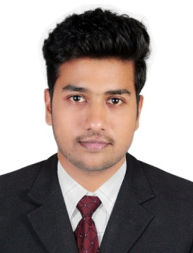
CURRICULUM VITAE

ABI.
MBA IN (LOGISTICS AND SUPPLY CHAIN)
E-mail ID : abi.380081@2freemail.com

OBJECTIVE
I am looking forward to work in an Organization where I can apply my experience and enhance my knowledge and skills for the development of the Organization as well as personal and professional development.
skills highlight
- Flexible and able to work independently and in a team setting.
- Good communication and interpersonal skills.
- Aggressive target oriented personality and very committed towards the assignment given to me.
- Customer friendly attitude.
- Capability to establish strong working relationships with internal departments and external agencies.
Professional Experience
Company name | LCL LOGISTIX (INDIA) PVT.LTD | Location | Cochin international airport, Kerala
From | March 10 ,2016 | To | February 23, 2018
Position | Logistics/cargo executive | Country | India
Job role | 1.Documentation  2.Ensure all operational activities are completed on time  3.Immedietly report any amendments to the customs declarations forms to the  Manager  4.coordination of transportation
Educational Background & Qualifications
Academic Qualification
- MBA in Logistics and Supply chain management from Bharathiar university,2014-2016
- Diploma in Supply chain and transport modes (IATA),2016
- Logistics and supply chain management from Patriot aviation college,2016
- Logistics management NORKA ROOTS,2015
- Shipping documentation (sea fright and air fright), Login Institute of Logistics,2016
- Bachelor of Science-Physics from St Thomas College,Thrissur,India-2011-2014
- Higher Secondary Education from Model Boys H.S.S, Thrissur, India 2011
Software Skills
- SAP ERP,2016
- Fully proficient in word, Excel, power point and outlook.

Project expereince
I have done my Bsc Final Project at "Agricultural University Mannuthy" and "St Thomas College Thrissur". The project topic was "Gamma Radiation on Different Soils".
Personal strength
- Creative, highly motivated and decision maker to prioritise work and meet deadlines.
- Detail oriented, proficient organizer.
- Excellent interpersonal and communication skills, good dealing staff members.
- Problem solver with capabilities to identify discrepancies and resolve the issues accurately.
- Hard worker and enjoy taking up new challenges.
- Professional with pleasant personality.
- Computer knowledge in MS office.
Personal Details
Date of Birth | 09.04.1993
Nationality | Indian
Sex | Male
Marital Status | Single
Religion | Muslim

Interests |  | Languages | Read | Write | Speak
Listening Music, Traveling, Surfing the Net, playing cricket and football, photography |  | English | Yes | Yes | Yes
 |  | Hindi | Yes | Yes | No
 |  | Malayalam | Yes | Yes | Yes
 |  | Arabic | Yes | Yes | No

DECLARATION

I hereby declare that the information furnished above is true to the best of my knowledge.

