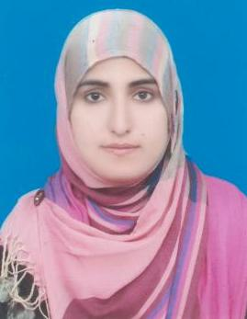
Email: aqsa.380105@2freemail.com

AQSA

Objective:
To work with a team reputable and dynamic organization that provides challenging work and to keep up with growing technological advancements and to perform a vital role where my knowledge can be utilized and skills can be polished.

Experience:
- I have taught as Teacher of English in Narowal Public School & College Narowal from 15 May, 2015 to 4 December, 2017.
- I have been performing the duties of Coordinator of English department from the last one year up-till now.
- I am also the member of School discipline committee.
- I worked as an expert fine arts teacher (Class décor)
- I have been worked on creative Projects.
- I have been arranged extra co-curricular work too.
- My thesis deals with the critical study on (Developing writing skill through communicative approach at intermediate level).

Education:
- Master In TEFL (Continue)
- Master in English (2011-2013) University of the Education
- Bachelor of Arts (2009-2011) University of the Punjab
- Faculty of Arts (2007-2009) Board of Intermediate & Secondary Education Gujranwala
- Matric (Science) (2005-2007) Board of Intermediate & Secondary Education Gujranwala

Professional Education:
- Bachelor Of Education (B.ED) Allama Iqbal Open University
- Post Graduate Diploma in English Language Teaching (PGD ELT) University of Punjab

Computer Skills:
- Basic
- MS Power Point
- MS Outlook
- MS Word
- MS Excel
- Web browsing

Personal:
Date of Birth: 14 October, 1992
Nationality: Pakistani
Religion: Islam
Marital Status: Married
Visa Status: Visit Visa

Language Proficiency:
English, Urdu, Punjabi

Others:
Have good communication Skills

Interest:
Reading Books, Travelling, Listening music.

Reference:
Reference may be furnished whenever require

