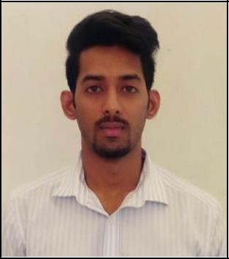

Allan
E-mail ID: allan.380122@2freemail.com
-----------------------------------------------------------------------------------------------------------
Career Objective

Seeking a challenging and rewarding position in Accounting or Auditing, whereby I could finally utilize my academic knowledge as well as experience gained throughout the career.

Work Experiences
2016 to current |  | Accountant and Audit Assistant with
 |  | P.P Chandak & Co., Nashik, India.
2015 to 2016 |  | Accounts Assistant with Datamatics Software
 |  | services Limited, Nashik, India in their
 |  | “FASUS Tax & Accounting” Department.
2014 |  | Internal Auditor (on assignment) with
 |  | ABB India Limited, Nashik, India
Academic Qualifications

- Master of Commerce from Pune University, India with first class in 2017

- Bachelor of Commerce from Pune University, India in 2014

Computer Skills

- Well-verse with Tally ERP 9.0 & 7.2 Software

- MS-excel, MS-Word and MS PowerPoint
- Internet operations and e-mail handling

JOB PROFILE

- Accounting

  - Invoice verification along with purchase order and goods receipt notes to ensure that liabilities are recorded with agreed terms and conditions.

  - Excise duty documents verification to establish that duty is paid in accordance with the statutory laws and that duty drawback is claimed in case of duty exemptions such export.

  - Verifying financial statements, ledger accounts and vouchers.

  - Verifying subsidiary accounts such as fixed asset register.
  - Processing Payments and Invoices (GST & VAT).

  - Physical stock verification and reporting of discrepancies.

  - Examining various documents and records for accuracy and compliance of statutory laws and company manuals.

- Auditing

  - Internal check and controls verification in different companies as assigned by the audit firm.

  - Identification of risks and reporting to the management.

  - Suggesting control measures and process improvements to the business in discussion with the Audit Manager.

  - Team leader for bank audits – Holding discussions with bank managers and assign different tasks to the clerical staff and coordinating between Audit Manager and staff for the smooth flow of audit and reporting within tight time schedule.

  - Experience in various banks including nationalised and private banks:

    - Concurrent Audit

    - Statutory Audit

    - Internal Audit

Personal skills

- Hard working and sincere

- Excellent communication skills
- Well focused on task on hand

- Quick learner
- Team Leader

Personal Information

Age & date of birth: 24 years; 08-11-1993

Gender: Male

Language Proficiency: English, Hindi, Marathi & Malayalam

