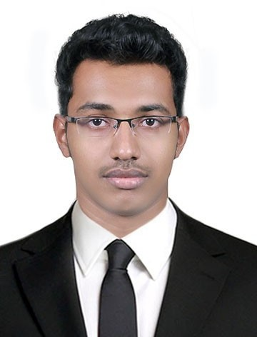PRASANTH
Email ID: prasanth.380134@2freemail.com
Dubai, UAE

PROFESSIONAL OBJECTIVE:
To associate with vibrant organization which allows me to put my competencies to the best use and add value to the organization contributing to growth as an individual.

EDUCATION

MBA (MARKETING & HRM) 2013
Srinivas Institute of Management Studies, Manglore, Karnataka,India

BCA (Bachelor of Computer Application) 2011
Srinivas Institute of Management Studies, Manglore, Karnataka,India

12th 2008
Government Higher Secondary School, Udma, Kerala, India

10th 2006
Government High School, Chattanchal, Kerala, India

KEY QUALIFICATIONS

- 3 + year’s experience working as a Coordinator in UAE & India.
- Expertise knowledge in business management.
- Can operate on subjective, interpersonal, institutional and environmental levels.
- Highly skilled in promoting and modelling a culture of hospitality.
- Ability to transform resources into utility.

CORE SKILLS

- Ability to lead and motivate teams to achieve certain set goals.
- Quality to analyse complex situations and to take appropriate actions.
- Skill to communicate, motivate, mentor and delegate.
- Ability to get fit into any kind of work environment.
- Advocate and organize work.
- Coordinating and controlling activities by taking quick and right decision.
- Computer savvy.
- Tactful approach.

COMPUTER PROFICIENCY

- Microsoft Dynamics NAV
- Microsoft Word, Microsoft PowerPoint , Microsoft Excel

MAJOR ACADEMIC ACCOMPLISHMENTS

  - Have participated in many National level management fest.
  - Have won many prizes for participating in Debate & Quiz Competitions.
  - Have selected as project toper during the Graduation program of BCA (Bachelor of Computer Application) with 96 percentages of marks.
  - Attended national level Management conferences, seminars and workshops.

WORK EXPERIENCE

COMPANY NAME : THAKRAL IT SERVICES(THAKRAL GULF FZE),DUBAI,UAE DESIGNATION : SERVICES & SALES CO-ORDINATOR
DURATION : 23-MAR-15 TO PRESENT RESPONSIBILITIES :
- Worked as the single point of contact to the customer for all types of service requests.
- Acted as the sales head for INO mobile phones, UAE. Coordinated INO mobile phones promotion and sales .
- Confers with users or reviews requests for services to identify requirements ; coordinates with implementation
team, contractors, or vendors as needed to provide required services or support.
- Allocated resources to meet customer requirements efficiently and effectively.
- Assisted the sales team, focusing mostly on managing schedules and the distribution of any sales documentation.
- Respond to complaints from customers and give after-sales support when requested.
- Stored and sorted financial and non-financial data in electronic form and present reports.
- Handle the processing of all orders with accuracy and timeliness.
- Negotiations were done with vendors on price and delivery.
- Prepared all purchase and sales documents.
- Inform clients of unforeseen delays or problems.
- Monitor the team’s progress, identify shortcomings and propose improvements.
- Assist in organizing events and meetings.

MAJOR PROJECTS HANDLED

Coordinated Structured Cabling & Wifi projects at various MAF shopping malls (Sharjah City Center, Ajman City Center, Mall Of Emirates, Deira City Center, Mirdiff City Center , Fujairah City Center) & MBC Studio Headquarters at Media City and Studio City.

COMPANY NAME : STRAIGHT LINE IT UNIT,KERALA,INDIA DESIGNATION : HR CO-ORDINATOR
DURATION : 02-JUN- 14 TO 05-FEB-15 RESPONSIBILITIES :
- Coordinated HR activities of the firm and ensured the goals are met.
- Handled documentation and stored it in electronic formats.
- Processed payroll.
- Undertaken community initiative.
COMPANY NAME : LORETTO EMPORIUM,KARNATAKA,INDIA DESIGNATION : HR CO-ORDINATOR
DURATION : 08-JUL-13 TO 30-JAN-14 RESPONSIBILITIES :
- Coordinated marketing and HR activities of the firm.
- Undertaken research activities related with location search and brand positioning.
- Framed promotional efforts of the firm and monitored the effectiveness of the newly implemented strategies.

PERSONAL INFORMATION
Date of Birth/Age : 13th November 1989/28 Years Marital Status/Gender : Single / Male
Nationality : INDIAN
Languages known : English, Hindi and Malayalam Visa Status : JAFZA EMPLOYMENT VISA(CANCELLED)

DECLARATION:
I hereby declare that the above mentioned information is true to the best of my knowledge and belief.

