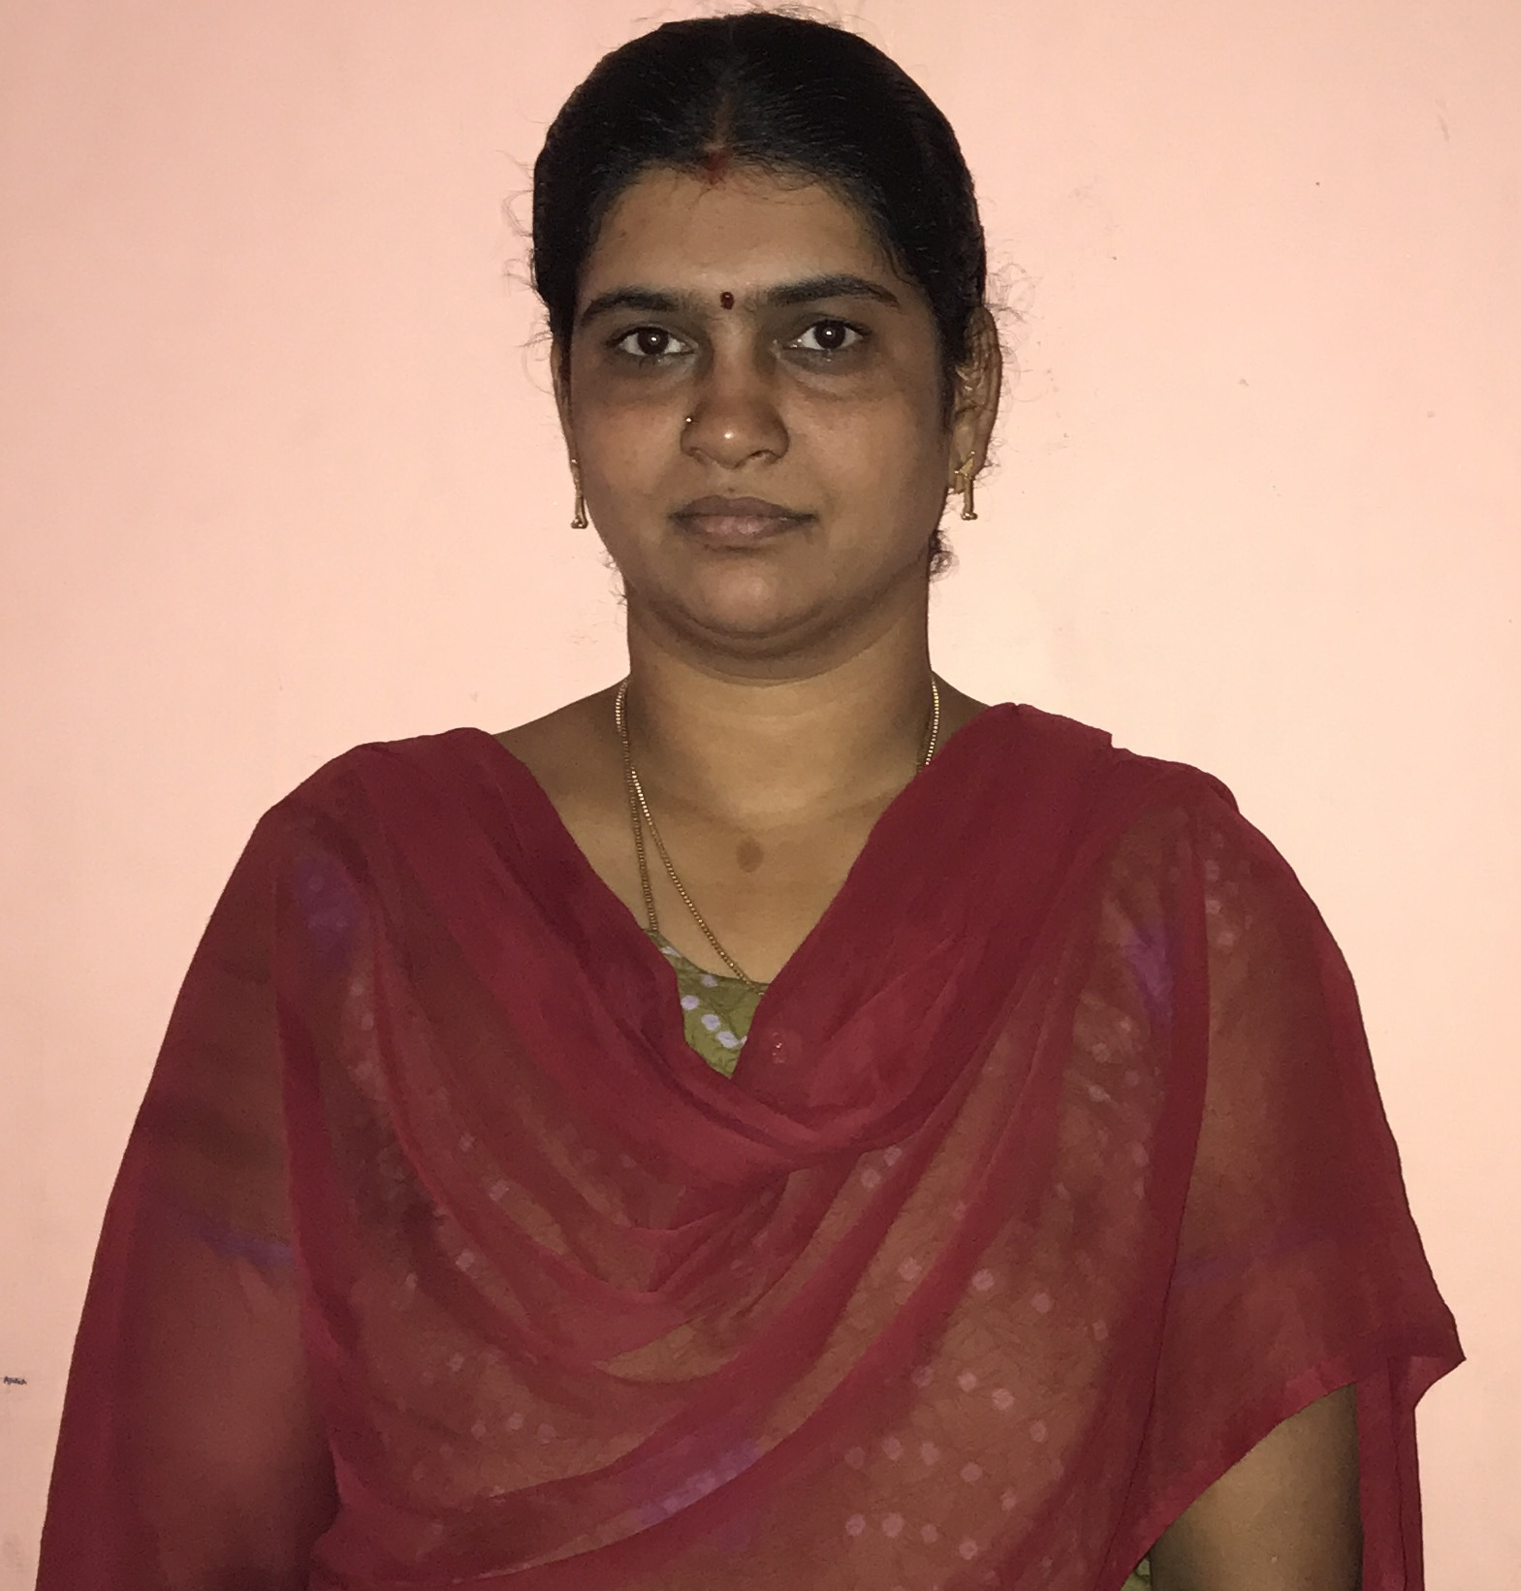
LAKSHMI

Email ID: Lakshmi.380148@2freemail.com

STRENGTHEN AREA’S

- Proficient in MS Office
- Supervising
- Data Analysis
- Customer Service Practices
- Mediation and Conflict resolution techniques

Professional Experience

ALSTOM Transports Pvt Limited

From July 2017 – March 2018

Department Assistant to the Director of Project Engineering

- Kept detailed records of important conferences such as board meetings and committee meetings.
- Word-processed documents, edited and proofread when necessary, wrote thank-you letters and prepared mailing lists.
- Managed incoming and outgoing mail/emails/checks
- Helped department employees with administrative issues in the people management tool on a regular basis.
Computer Age Management Services Pvt Ltd

From May 2007 – October 2008

Senior Customer Service Executive, East Zone

As a senior customer service executive coordinated with the AMC of the Eastern Zone

My responsibilities include:

- Built and managed solid client relationships, acted as a liaison with AMC personnel to effectively resolve any client issues.
- Checked for quality and assurance of client and customers upon release and presents fixes for problems that are detected
- Formulated ideas to create new and updated reports that will help find errors before they become problems.
- Assisted fellow team members in training of both client and investors.
- Helped clients to solve issues in an effective and friendly manner.
- Answered all incoming calls and requests to the banking center
- Provided both substantive and technical assistance

Club Mahindra Holidays

- From October 2006 – June 2007

Customer Service Executive

- Maintain a high-volume workload within a fast paced environment.
- Assisted an average of 550 clients in any given week and consistently met performance benchmarks in all areas (speed, accuracy and volume).
- Helped company attain the highest client service ratings (as determined by external auditors) - earned 100% marks in all categories including communication skills, listening skills, problem resolution and politeness.
- Completed voluntary client relations training to learn ways to enhance customer satisfaction and improve productivity.

K G Denim

From July 2005 – July 2006

Apprentice

- Successfully tracked unit movements and accountability of all personnel Prepared correspondence and travel orders
- Composed spreadsheets, letters, rosters and various reports utilizing programs such as Microsoft Word and Microsoft Excel to route up through the higher chain of command Recorded minutes at meetings and conferences for supervisors
- Performed routine clerical tasks quickly and accurately
- Processed and maintained records of various transactions

Educational Qualifications:

Course | Institution | Board / University | Year of Passing
Diploma In Instrumentation & Control Engg | BCMWPC | Tamilnadu State Board | 2005
SSLC | KendriyaVidyalaya | CBSE | 2002

Major Strengths

- RESPONSIBILITY
- RELATOR
- INCLUDER
- LEARNER

Other Key Strengths

- Ability to work in a team and competent to handle more volumes.
- Excellent Analytical Skills and Strong Customer Focus
- Quick Learner.
- Solid understanding of Business Needs and requirements
- Developed a positive and productive work environment with co-workers
- Established and maintained highly confidential information, documents and records.

Personal Details
- References: Will be Provided On Request
- Gender : Female
- Date of Birth : 21-Feb-1987
- Marital Status : Married
- Nationality : Indian

