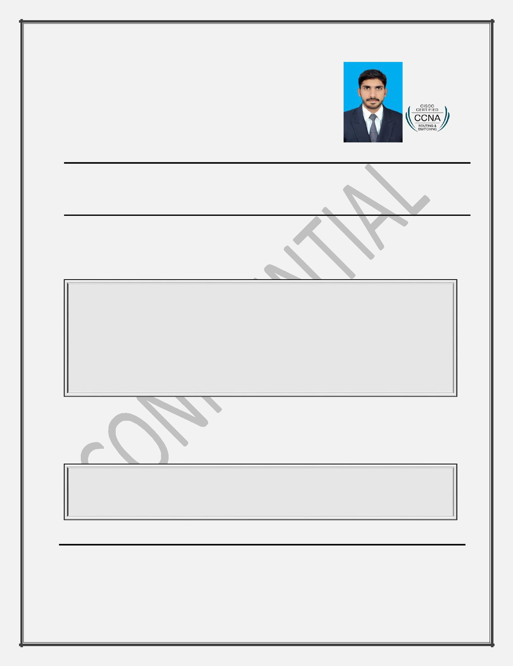
CURRICULUM VITAE

AMEEN

Residential Address: Abu Dhabi, UAE; Passport: Pakistani

Email: amen.380151@2freemail.com
Marital Status: Single
Visa Status: Employment Visa

Objective

Seeking a position to utilize my skills and abilities and achieve professional growth while being resourceful, innovative and flexible. To add valuable assets to your organization as an active member.

Work Experience

• International Experience:

Easy Software Solutions L.L.C, Abu Dhabi, UAE.

Network Supervisor

July 2017-Present

Networking, Switching, Routing and troubleshooting

Installation, maintenance and troubleshooting of IP & Analog CCTV camera

Biometric Time Attendance System

Access Control System
PABX and Ip telephones

Installation and troubleshooting of wireless and other printers Installation and troubleshooting of all types of windows

Installation and Configuration of Internet (Router, access point, Wi-Fi extender and cloud) Configuration of DVR & NVR

Configure Remote access of cameras on Mobile and Computers

• National Experience:

Arfat Cyber Solutions, Rawalpindi, Pakistan Network Support Technician

Oct 2016-April 2017

Data entry in Microsoft word and excel

Computer networking and cabling
Maintenance and troubleshooting of windows

Camera installation

Professional Certificate
Certificate | : | CCNA (Routing and Switching)
Exam Code | : | 200-125
Grade | : | Pass

1

CURRICULUM VITAE

Education

Qualification | Marks/CGPA | Grade | Board/University
BSc Electrical | 2.98/4 | C+ | Gomal University
(Telecommunication)
Engineering
Intermediate | 758/1100 | B | BISE D.G.Khan
Matriculation | 755/1050 | A | BISE D.G.Khan

Training Certificate

- Linux (Jan 2017-Feb 2017) Corvit reaching end to end

- CCNA (R&S) Nov 2016-Jan 2017 Corvit reaching end to end

Academic project

- Voice Communication Through Li-Fi Technology

Skills

Computer Skills:

- Microsoft Windows and Office applications (Word, Excel, Office)

- Computer Software Installation and Hardware Repair

- Basic knowledge of Adobe Photoshop

- Basic knowledge of MATLAB

- Operating Systems and Troubleshooting: Windows XP, Windows 7,8

Professional Skills:

- DHCP, EIGRP, IPv4 and IPv6 addressing, Infrastructure Components, LAN Switching, Network Management, Network Security, OSPF, RIPv2, Static and Dynamic Routing, Troubleshooting, WAN Topologies, eBGP, PPPoE, FHRP, GRE, QoS

- CCTV Camera Installation

- Bio-Matric Attendance System

- Door Access Control

Extra-curricular activities
Work with Derayian Debating society (DDS) as a media secretary | 2014-2016
Work with Community Help Community (CHC) as volunteer | 2015-2016

Languages Spoken

- English

- Urdu

- Arabic (conversational)

