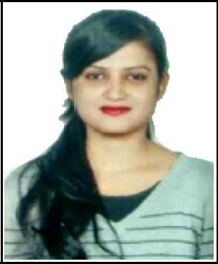
Curriculum vitae

JOYCE

DUBAI UAE

E-MAIL: joyce.380232@2freemail.com

CAREER Objectives:

To obtain a position as a Human Resources Executive that will utilize my experience, knowledge and skills to fulfill the needs , goals, vision and mission of the company

Educational Background:

MBA | : International Business School in Bharathiar University.
Bachelor’s Degree | : B. com Sri Y.N College in Nannaya University
Inter | : MEC Sri Surya Junior College
SSLC | : Mission High School
Professional Experience:
❖ Company | : Corporate Ladders
❖ Job Role | : Human Resource Executive
❖ Period | : 0-1 year
❖ Project | : Effectiveness of Recruitment
❖ Location | : Marathahalli, Bangalore in India.

Skill summary:

- Interpersonal and communication skills

- Office Administration Skills.

- Quick Adaptability to new technologies

- Quick learner

TECHNICAL SKILLS:

- Proficient with MS office

- Email, Social Media, and Blogging

Interpersonal skills;

- Confident and determined

- Ability to rapidly build relationship and set up trust.

- Ability to cope up with different situations.

- Flexibility, adaptability , grasping power

- Good communication skills.

- Leadership / interpersonal

Awards / achievements:

- Seminars

- Cultural activities.

- Debate

- Sports

Personal details:
Nationality | : |  | India
Date of Birth | : |  | 04/07/1995
Gender | : |  | Female
Religion | : |  | Christian
Marital Status | : |  | Single
Visa Status | : |  | Visit Visa
Language Known | : |  | English ,Hindi and Telugu

Strengths:

- Dedication to work and strive for goal in life.

- Self – Confidence and interested to learning more.

- Good team player skills , ability to withstand pressure

- Leadership and decision making capabilities.

- Flexible to work in different environments.

- Good oral, written communication and presentation skills,

Declaration:

I hereby declare that the above mentioned statement is correct 7 true to the best of my knowledge and belief

​JOYCE

