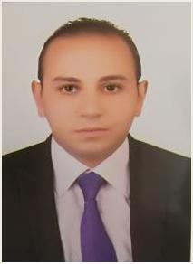
Ramadan

E-mail : Ramadan.380292@2freemail.com

Personal & Information
 | Nationality |  | : |  | Egyptian
 | Religion |  | : |  | Muslim
 | Date of birth |  | : |  | 29th March , 1985
 | Place of birth |  | : |  | El-Mahalla El-Kobra
 | Visa Status |  | : |  | Resident
 | License |  | : |  | (M.O.H) UAE
 |  |  |  |  | General Practitioner

Educational Qualification:

M.B.B.S Bachelors Degree In Medicine and surgery
Grade : Accepted
Year Of Graduation : 2013
Mansoura University , Egypt.

Language :

▪ Arabic language " mother tongue " oral and writing ( excellent)) .

▪ English language " spoken–writing–listening–reading ( excellent)) .

1

Experience :

- Trainner G.p.Doctor at Mansoura University Hospital after Graduation From March 2014 to August 2015.

- worked as G.P. Doctor at Private El Zawahry Hospital from March 2014 to August 2015.

- worked at Tabark Children Hospital as Pediteric G.p. from 2014 till 2015.

- worked as G.p. Doctor at Primary Health Care Government Of El Mahalla El Kubra Egypt (Maternal Healthcare and Neonate Immunization) from January 2016 till February 2017.

- worked as G.P. Doctor at Dar Elfayrouz Hospital (Emergency Unit ) from September 2015 till January 2018.

- worked as ICU Resident Doctor at ElMahalla Government General Hospital (Intensive Care Unit ) from February 2017 till now.

2

