RESUME

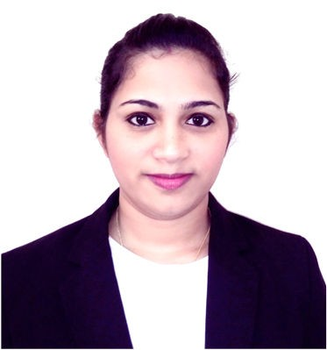ASWANI
SHARJAH
Email: aswani.380322@2freemail.com

CAREER OBJECTIVE
To work in an organization where culture of freedom and working for initiatives is ensured, facilitating my contribution through thoughts and action to the company’s vision and thus achieve self-development by playing a significant role in building the organization.

WORK EXPERIENCE
- Worked as a Sales Executive cum Customer Support Asst. in Global Net Systems, Kollam, Kerala, India from September 2014 to March 2016
RESPONSIBILITIES
  - Customer support, inquiries and information management
  - Client’s queries and complaints.
  - Developed strong relationships with customers – maintained cordial relations with existing and new customer.
  - Maintained accounts of sales made, new orders, and customer details.
  - Submitted timely and accurate reports related to the arrival of new stock or remaining supplies in the store.
  - Provided online after sales support

PERSONAL SKILLS
- Excellent interpersonal and communication skills.
- Optimistic and confident outlook towards life.
- Ability to identify growth, learn new things and constantly upgrade my skills.
- Ability to manage people diplomatically and tactfully
- Time management skills, teamwork and multitasking.
- Quick learning and Effective study skills.
- Fluent in English

EDUCATIONAL QUALIFICATIONS

Course | Board / University | Year | %
Bachelor of Technology – IT | Kerala University | 2010- 2014 | 70%
HSE | Higher Secondary Board, Govt. of , Kerala | 2010 | 80%
SSLC | Board of Public Exams, Kerala | 2008 | 82%

COMPUTER PROFICIENCY:
- Windows (98/2000/XP/7)
- Having good working knowledge of Windows (OS), MS Word, MS Excel & Power Point.
- Networking
- Database : MySQL, SQL

PERSONAL PROFILE
Date of Birth : 20-02- 1993
Gender : Female
Nationality : Indian
Marital Status : Married
Languages Known : English, Malayalam & Hindi Hobbies : Listening Music.
Visa Status : Visiting Visa
(eligible for husband visa)

DECLARATION
I hereby declare that all information provided by me is factual and correct to the best of my knowledge and belief.

