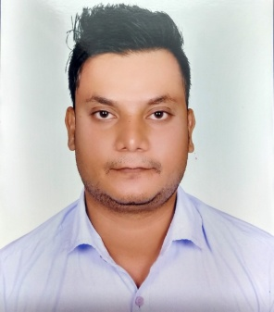
RAMEEZ
3D ARTIST/3D MODELLER/3D VISUALIZER

Email – rameez.380331@2freemail.com

CAREER OBJECTIVES  Attributes | - To work as highly successful professional with varied rich hand in experience.  - This will help me to increase my potential and work efficiently with the  - Organizational needs.  - Quick learner  - Hard worker  - Loads patience  - Punctual  - Sincere & Determined
Skills | Adobe Photoshop Autodesk Maya  Autodesk Match Mover Adobe Premiere Autodesk Mud Box Pixologic-Zbrush  PF Track MS Windows  Adobe After Effects Real Flow  Adobe Sound Booth Mac Os  Autodesk 3ds Max Eyeon Fusion  V-ray Cinematography  Autodesk Autocad  Photography
Other Skills  Work Experience | Computer Hardware, Networking, Mobile Hardware/Softwares, Digital Painting, Drawings, Music Production (Mixing-Compositing-Remix)  1 Year experience as a SYSTEM SUPPORT EXECUTIVE in BRAINWARE  1 Year experience as a FREE LANCING
Education | 10th passed in 2009 with 48.86% from W.B.B.S.E.  Higher Secondary passed in 2011 with 43.17% from W.B.C.H.S.E.  Bachelor Of Arts in Advance Visual Effects passed in 2016 55% from M.A.A.C (MAYA ACADEMY OF ADVANCE CINEMATICS)/I.G.N.O.U
Awards | Best Generalist Award In (2014)  (M.A.A.C) Maya Academy Of Advance Cinematics
Personal Details | Date of Birth : 07/10/1989  Gender : Male  Marital Status : Unmarried  Religion : Muslim  Nationality : Indian  Languages Known : English Urdu, Hindi Bengali, and  (Read, Write & Speak)  Strength : Honesty, Truthfulness  Hobbies : Watching Hollywood Movies, Playing Games On Computer Listining Music-Songs, Playing Football and Cricket

Passport/Visa Details

Country Code : IND
Place Of Issue : Kolkata

Visa Status : Visit

