PROFESSIONAL EXPERIENCE

CARRER SUMMARY

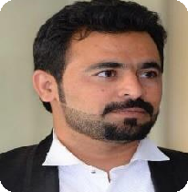

HAIDAR

City, Dubai -UAE

Haidar.380371@2freemail.com
DOB -13 Mar 1991
Visa-Employment

To lead an organization in the field of LOGISTICS and help it for achieving its strategic objectives through dedication and commitment by using its resources and competencies efficiently and effectively

Core Competencies
- Custom's declaration (Bill of Entry).

Transit bill of entry of any kind.
- Import and export documentation.

Air waybill typing.
- Cargo handling.
- Row to Row clearance.
- Exit paper typing.
- DP World Payments.
- Perishable goods documentation.

Vehicle import and export.
- MS Office.
- Dubai Trade (Mirsal 2).
- Type Writer for Exit pappers.
- 3 years’ experience in “Mirsal 2” (DUBAI TRADE) import and export documentation, custom clearance and forwarding.
- Qualified as Bachelor of Art a, from Pakistan.
- Well versed in MS Office and Mirsal 2.
- A dedicated team player with demonstrated abilities, who can bring to Your business additional professionalism, passion, productive ideas, enthusiasm and out of the box thinking with practical work experience.
- Possess excellent planning, organizing &problem solving skills.
- Excellent communication skills & can work under pressure.
- Proven ability together, collate and use data effectively.
- A Quick learner and can handle any type of Dubai Custom's work and import/export documentation and activities.
- Effectively inter facing with people at all levels.
- Strong leadership, interpersonal & communications skills

EMPLOYMENT HISTORY

Designation: Custom Clearing Agent
Nume-Al-Kamal Clearing and Forwarding LLC. (11 June 2014 to 08 April 2017)

JOBPROFILE:

- Ensure to prepare accurate and correct custom's declaration (Bill of Entry) according to provided documents.
- Import and export documentation and custom clearance.
- Vehicle import and export clearance and documentation.
- Sea, Air, Road and coastal documentation and clearance.
- Transit bill of entry of any kind.
- Custom Inspection Booking
- "ROW to ROW "clearance.
- DP World Payments.
- Air Waybill typing.
- Claim submission.
- Exit paper typing.
- Cargo handling.

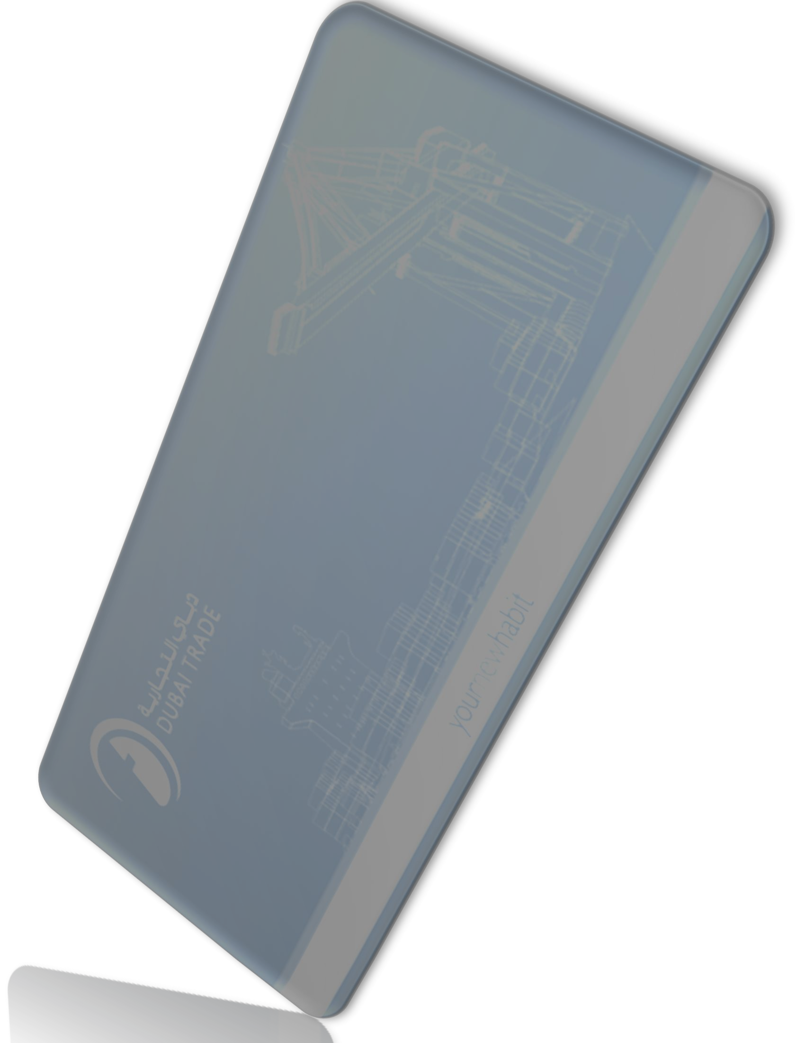
I am a very good and active user of Dubai Trade; I can handle any kind of custom’s activities for the clearance of the shipment. I have a very good experience in clearing and forwarding of the cargo shipments, and have a good sense about logistics activities.

3.5 years’ experience in logistics,
cargo handling and documentation, preparation of import, export and transit documents. I am properly aware of Dubai Customs rules and regulations and active in using accurate HS.CODEs and good’s description
Designation: Custom Clearing Agent
DASKA CARGO Clearing and Forwarding LLC. (22 April 2017 as on)

JOBPROFILE:

Pharmaceutical’s goods documentation.
- Perishable goods documentation.
- FIRS preparing. FTIR preparing

PROFFESSIONAL QUALIFICATION
• Bachelor of Arts, Government College University Faisalabad,(Pakistan).
• Intermediate in Arts, Faisalabad Board (Pakistan).
• Matriculation (Pakistan).

COMPUTER SKILLS

- MS Office.
- Mirsal 2 (Dubai Trade)
•Type writer for Exit typing.

PERSONAL PROFILE

- Date of Birth: March 13th, 1991.
- Nationality: Pakistani.
- Visa: Employment.
•Languages: English, Urdu, and Hindi

