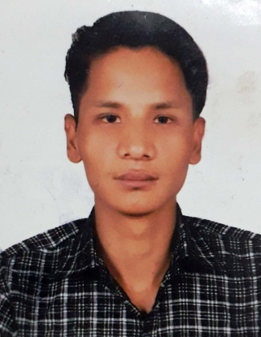
DIPENDRA

Email: dipendra.380436@2freemail.com

OBJECTIVE

Seeking a good career and holding a responsible position in the reputed organization and ensure credible performance to work towards exceeding the set goals contributes for the organization.

PROFILES
- Hard working and dedicated
- Good communication and analytical skills
- Can work under pressure with time bound performance
- Easy adaptability to situations

EDUCATIONAL ATTAINMENT
- SLC from Nepal Passed from Shree Gyanda Secondary School, Nepal
- HSEB FROM MAKAWANPUR MULTIPAL COLLEGE,NEPAL

COMPUTER SKILLS & TRAINING
- Basic Knowledge of Computer
- Trained from CTEVT OF BUILDING ELECTRICIAN

WORK EXPERIENCE
- Worked as Sales man from 5-10-2016to 26-12-2017 in Narayani Mall, unique shop
Responsibilities
- Displaying Items
- Serving customers.
- Dealing with any queries & complaints.
- Advising customers at their purchases.
- Assisting the customers for any cash or card payments.
- Ordering, managing & taking out stocks.
- Making sure sales targets are met.

PERSONAL DETAILS

Date of Birth : 10/10/1992
Nationality : Nepalese
Gender : Male
Marital Status : Unmarried
Languages Known : English, Hindi & Nepali

PASSPORT DETAILS

Date of Issue : 24/09/2014
Date of Expiry : 23/09/2024
Visa Status : Visit Visa

DECLARATION

I hereby declare that the particulars furnished above are true to the best of my Knowledge and belief

