PERSONAL INFORMATION | Mustafa
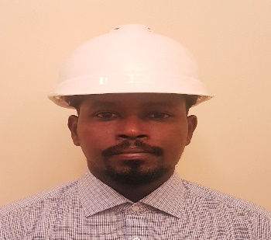
 | Mustafa.380437@2freemail.com
 | Date of birth October 1987 | Nationality Sudanese

POSITION  summary | Civil Engineer  Energetic and self motivated construction manager consistently involved in all facets of building construction from pre-construction to hand over. proactive and experienced in managing a variety of construction teams and sub-contractors on projects. Successful in creating effective communication between personal general contractors and the management team. safety oriented who works efficiently and effectively to complete project on time and within budget. Diligent who consistently monitors site works to ensure proper compliance with building and safety codes.  Supervising residential buildings and project management in overseeing contractor's work with consulting firms.  Experience in reviewing structural shop drawings. Revise Interim Payments for Client based on the Progress of Works. Measure and value the work done on site. Knowledge of construction management. Strong multitasker with skill in functioning well in a high-pressure work environment.

EDUCATION AND TRAINING

B.Sc. (honour) in Civil Engineering
University of Khartoum, Khartoum (Sudan)

WORK EXPERIENCE

2015–2017 | Site Project manager – Alrajhi Saudi group --- KSA
▪​ Control the quality and quantity of construction.
▪ prepare payments according to actual work in site
▪ Daily, weekly & monthly reporting.
.
.

2011–2015 | Khartoum centre for technical consultations and resources development  - Construction supervision  - BOQ preparation  - Design & design check
 | supervision
The project is multi-story reinforced concrete buildings (10 floors), my responsibility was
supervision of : Construction work.

PERSONAL SKILLS

Mother tongue(s) | Arabic
 | English
Other language(s) | UNDERSTANDING |  | SPEAKING |  | WRITING
 | Listening | Reading | Spoken interaction | Spoken production

Communication skills | - Excellent contact, communication skills, resolving conflicts and motivating others. ​​

Additional course | - Iosh managing safely

Job-related skills | - ​Design principles, construction methods and materials.  - Working with prints, maps, drawings and models, as well as computer programs used in architectural design and construction.

Software skills | Microsoft office (Word, Excel ...).  AutoCAD.  Etabs & Safe.

