JACKSON
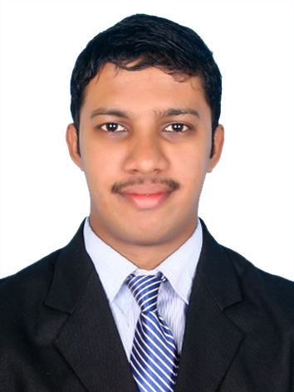
jackson.380461@2freemail.com
B Tech, MBA

CAREER OBJECTIVE
To take up a challenging job which enhances my talents and improve them in a good way for the betterment of me as well as the organization.
WORK EXPERIENCE
- RR DONNELLEY, Technopark, Trivandrum, Kerala, India (30th Dec 2016 to 5th Mar 2018)
Financial Associate
- Doing the Fund Scrub Process in Updating the funds with the Fund Template & PEK.
- Vesting Process in Calculation of the Employer’s Contribution to the Plan.
- Reallocation Day 1 & Reallocation Day 2 Process in Management of funds that deals mainly with the before and after trading process of the funds.
- Investment Prep Process that deals mainly with the comparison of the funds with the Employers Fund Sheet and the Fund Templates.
- Payroll Process in setting up the correct day for the management of their salaries.
- Enrollment Process mainly dealing with the enrollment of the Employees to the Plan.
- Doing the Fund Setup Process in the Plan in the setting up of the Funds.
- Census Details are uploaded to the Plan for dealing with the Investment Process.
Research Associate
- Spreading of financial data to I-Metrics Work Bench Tool.
- Analysis of the Quarterly and Annual Financial Statements of US Banks
- Reviewing financial statements for Accuracy, Consistency and Completeness of data.
- Managing Web Search Analysis through SEC, Edgar Online and Company Website.
ACADEMIC QUALIFICATIONS

Course | Specialization | University/Board | Name of the Institution | Year | %
MBA | Finance & Marketing | KERALA | MSN Institute of Management & Technology, Chavara, Kollam | 2014-2016 | 71%
B.Tech | Computer Science Engineering | CUSAT | College of Engineering, Perumon | 2010-2014 | 62%
12th | Maths | ISC | Trinity Lyceum, Kollam | 2009-2010 | 74%
10th | General | ICSE | Trinity Lyceum, Kollam | 2007-2008 | 72%

STRENGTHS
- Communication, Coordination, Organizational and Time Management Skills.
- Positive Attitude to Work, Hard Working & flexible to work in Rotational Time Shifts.

EXTRA CURICULLAR ACTIVITIES
- Participated in many Management Fests, Seminars, Quiz at various Colleges.
- Has participated on an Audio Release of a book “Environment Management”.
- Has done a task on Interviewing an Entrepreneur “Mr. Spencer Cruz, Kadayil Group”.
- Internship done for 1 month at “CADD CENTRE” in doing all the Office activities.
- Trainee (PT) for 8 Months at “Sharekhan” dealing with the selling of Demat Accounts.
COMPUTER SKILLS
- C, C++, PHP, ASP.NET, MS Office, SPSS, I-Metrics, ARK etc.
PROJECTS AND SEMINARS DONE
MBA
- Project done on “A study on Impact of Investor’s Behaviour on Investment Decision”.
B.TECH
- Major project done in ASP.NET on “Double Guard”.
- Seminar on “Self-Replicating and Self-Modifying Programs in Fraglets”.
- Minor Project done in PHP on “TLC Medical Report”.
PERSONAL PROFILE

Sex | Male
Age, DOB | 25, 24/04/1993
Marital Status | Single
Languages Known | English, Malayalam, Tamil.

