SATISH
Satish.380537@2freemail.com
Mobile: Whatsapp +971504753686 / +919979971283

Senior Management Professional/ Business-Minded Growth Leader/ Sales Management Expert/ SBU Manager (Sales)

Professional Profile
Professional Profile

Seeking assignments with organization of high repute that will accomplish both personal as well as professional objectives

~Offering hallmark career manifested by vertical and horizontal movements in the career ladder~

Experience in contributing to double-digit growth figures; towards development & refinement of organizational vision & strategy; widespread sales training and presentation knowledge and building loyalty and long-term relationships with customers; reviewing operational records and reports to project sales and determine profitability

Strategic Account Development| Sales management | Customers Relationship Management | Training and Presentation

Ability to develop strategic solutions to build business from the ground-up, ascertaining a competitive edge, sustainability, and exponential organizational growth; discovered business potential &opportunities to secure profitable business volumes

Professional Certifications: Advanced Training Certificate for BOSCH Power Tools | Customer Service Training Certificate from Mercury| Team Building Selling By Objective training certificate | Negotiating Skill training certificate from IIM Bangalore

Breadth of experience across all aspects of strategizing, directing and executing operations. Oversee sales force, delivering training to incoming sales team members and building relationships with customers and the community to establish long-term business growth

■ Profile Summary
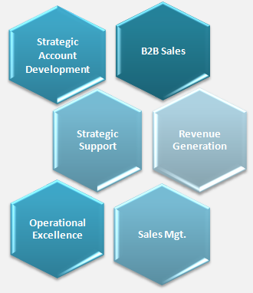
- Profile: Profit driven professional offering rich experience of 27+ years in driving development and execution of business development operations; managing overall businesses, delivering holistic solutions to carve a niche in highly competitive solutions and repeatedly produced sustained revenue and growth
- Career Contour: Presently working with M/s Dutco Tennant LLC –Dubai, UAE as SBU Manager. Trusted service record with M/s Techno flow LLC –Dubai, UAE as Sales Manager and worked with many other well known organizations.
- Expertise: Proven track record in establishing business units from scratch and drove them to accomplish top-line and bottom-line profitability. Vision to transform an organization’s growth by introducing innovative plans & strategies for targeting new sectors and customer segments
- Excellence Areas: Expert skills in developing quarterly and annual sales department budgets; delivered support to the sales team in writing proposals & closing contracts and planning & directing staff training and performance evaluations

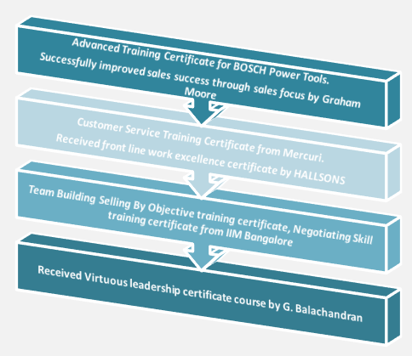
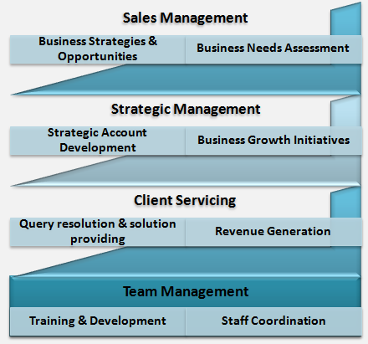
Professional Skills & Certifications

Foundational Skills
Strategic Planning | Sales Operations Management | Business Needs Assessment | Operational Planning & plan Execution | Strategic Account Development | Business Relationship Management | Leadership Acumen | Client Management | Customer Service Standards | Negotiation Skills | B2B sales | Budgeting | Training & Development | Resource Optimization | Revenue Generation | Quality Assurance | International and Analytical Skills | Business Development| MEP Contractors| Building Construction & Engineering Project Developers| Main Civil Contractors

Leadership Skills & Personality Traits:
- People engagement specialist utilizing logical and creative approaches to work while presenting specialist information to non-experts in an understandable form; natural leader with high degree of flexibility and managing large teams
- Thrives in time sensitive and challenging working environments; staunch believer of ‘Make Things Happen’ philosophy with persistence and good-decision making abilities

KEY HIGHLIGHTS | COMPETENCE DISPLAYED
- At M/s Dutco Tennant LLC –Dubai, UAE, Boosted regional market share by 12% within 24months and exceeded regional annual sales target by 20%.  - Successfully augmented revenue by 30% within the first year as Sales Manager  - Actively attended sales training camp and brought best practices leadership back to the company | Delivering best possible results for the organization, and showing determination, resourcefulness and a sense of purpose.
- At M/s Techno flow LLC –Dubai, UAE, dexterously hired 2 sales representatives over a 3 year period as well as exceeded regional annual sales target by 18%.  - Develop and maintain relationships with customers and the community to establish long-term business growth | Establishing programs on continuous workforce development including setting priorities for improvement actions, and establishing a culture of excellence
- At M/s. High Rise FZE –Sharjah, UAE, Oversaw sales force of 2 sales associates and exceeded regional annual sales target by 15%. Supported the sales team in writing proposals and closing contracts | Showcased a strong drive to excel in all avenues and lead from the front.

■ Career Review

August 2013- Present with M/s Dutco Tennant LLC –Dubai, UAE as SBU Manager
Value Proposition: Instrumentally oversaw sales force of 4 sales associates and supported the sales team in writing proposals and closing contracts and closed an average of 5 sales calls each quarter; developed quarterly and annual sales department budgets.

Key Deliverables: Please Confirm
- Strategic Planning: Developing and implementing competitive strategies to generate sales, to develop & expand market share to increase short and long term profits. Maintaining continuous alignment of operations scope with strategic business objectives, and provide recommendations to modify & enhancing effectiveness toward business result or strategic intent
- Business Development/ Sales management: Competently managing day to day functions of the business with an aim to generate profits and increase the inherent value of the business. Accomplishing business objectives by identifying & solving clients’ problems. Reviewing operational records and reports to project sales and determine profitability. Amplified revenue by 30% within the first year as Sales Manager
- Marketing & Product Sourcing Management: Reviewing market response / requirements and communicating the same to teams for accomplishing business goals; effectuating pre-planned strategies for accomplishment of performance milestones. Successfully handling product sourcing activities; design and implement an effective strategy to reduce costs of financial products and manage all sourcing processes.
- Customer/ Relationship management: Building relationships with customers and the community to establish long-term business growth. Accountable for contacting customers by phone and email in response to enquiries and promptly resolved all customer requests, questions and complaints.
- Quality Management: Ensuring maintenance of excellent relations with clients & maximum customer satisfaction through achieving service quality norms to generate avenues for additional business by monitoring speedy resolution of client queries
- Leadership Acumen: Providing leadership and vision to organization by assisting Top Management in the development of long range & annual plans, and with evaluation and reporting of progress on plans. Attend sales training camp and brought best practices leadership back to the company
- Team Management: Supervising team for achieving increased profitability. Motivating, monitoring team activities & taking feedback of executives about the upcoming trends in the markets for planning; Guiding and supporting front-line team through goal setting & reviewing measures.

April 2010 – July 2013 with M/s Techno flow LLC –Dubai, UAE as Sales Manager

Key Deliverables:
- Oversaw sales force of 4 sales associates; hired 2 sales representatives over a 3 year period. Dexterously increased regional market share by 30% within 36 months
- Identified streams for revenue growth by establishing cost-effective plans to build customer preference. Analyzed current growth rate of company and planning new strategy laid for improving the company’s turnover.
- Successfully developed quarterly and annual sales department budgets; evaluate operational records and reports to project sales and determine profitability.
- Handled marketing and product sourcing activities; sourcing products through industry research, customer requests, and benchmark analysis. Cooperated with stakeholders to guarantee agreement on terms and processes
- Enlarged revenue by 12% within the first year as Sales Manager and built relationships with customers and the community to establish long-term business growth

November 2008 - March 2010 with M/s. High Rise FZE –Sharjah, UAE as Manager

Key Deliverables:
- Developed quarterly and annual sales department budgets.
- Maintaining business with existing customers, as well as actively prospecting to develop new business in the assigned territory; analyzing process gaps and implementing way-outs to mitigate the same
- Exploring & developing new clients and negotiating with them for securing profitable business. Providing best products to suit their requirements backed up by prompt services
- Ensured that all communication activities are performed within functional budget

April 2006 - October 2008 with M/s Technical & Trading Est. –Dubai, UAE as Sales Manager

Key Deliverables:
- Reviewed operational records and reports to project sales and determine profitability
- Oversaw sales force of 9 sales associates; hired 3 sales representatives over a 2 year period.
- Successfully exceeded regional annual sales target by 23% and supported the sales team in writing proposals and closing contracts. Amplified regional market share by 10% within 15 months
- Instrumentally developed quarterly and annual sales department budgets. Planned and directed staff training and performance evaluations.

■ Prior Experience

Feb 1997- March 2006 with M/s Bhatia Brothers LLC –Dubai, UAE as Assistant Manager
Monitored sales force of 2 sales associates; exceeded regional annual sales target by 8%. Successfully closed an average of 5 sales calls each quarter; augmented regional market share by 15% within 60 months. Accountable for contacting customers by phone and email in response to enquiries

Jul 1995-Aug 1996 with M/s 3D International –Manama, Bahrain as Sales Executive

May 1992- June 1995 with M/s Karnataka Potteries (P) Ltd, Bangalore as Marketing Executive

April 1991-March 1992 with M/s Metal Closures Pvt Ltd, Bangalore as Marketing Engineer

■ Education Credentials

1990 Bachelor of Engineering from Bangalore University, Karnataka

■ Personal Details

Date of Birth: 20th September, 1966 | Linguistic Abilities: Hindi, and English

References Available Upon Request

